**New add-on features**

**Sales**

**Purchase**

**Payroll**

**Ready mix**

**Transportation**

**Logistic and New Trasportation**

**University**

**Sales Add-on:**

**Add filter by**

1-      Suppliers                            FROM TO

2-      Suppliers item code       FROM -TO

3-      Item code                          FROM -TO

4-      Department                      FROM TO

5-      Payment type  CASH , VISA , CREDIT , ALL   for sales report only

**SAL_R_024         SCREEN**

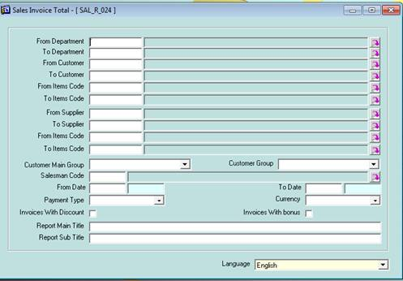

**SAL_R_032         SCREEN**

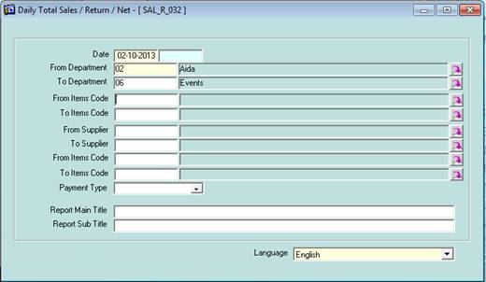

**SAL_R_013         SCREEN**

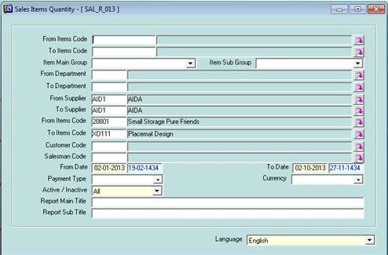

**SAL_R_015_R   ADD NET PROFIT , NET SALES**

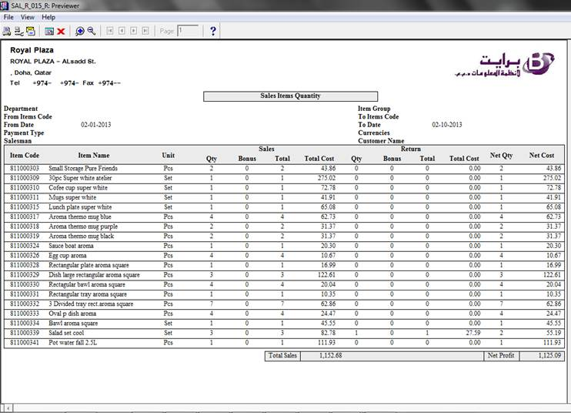

**SAL_R_036         SCREEN**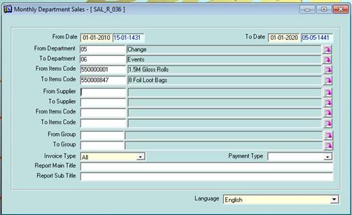

**SAL_R_038         SCREEN**

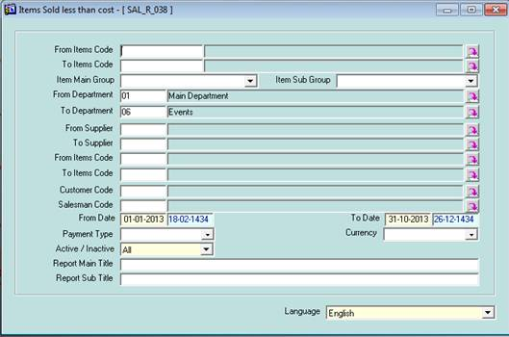

**SAL_R_203         SCREEN**

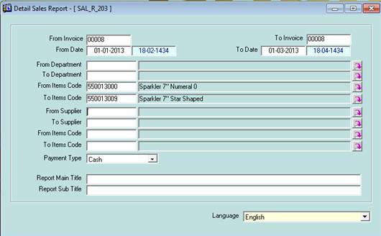

**SAL_R_204         SCREEN**

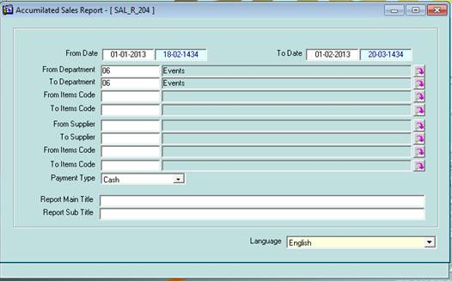

**Tax Formal Reports:::**

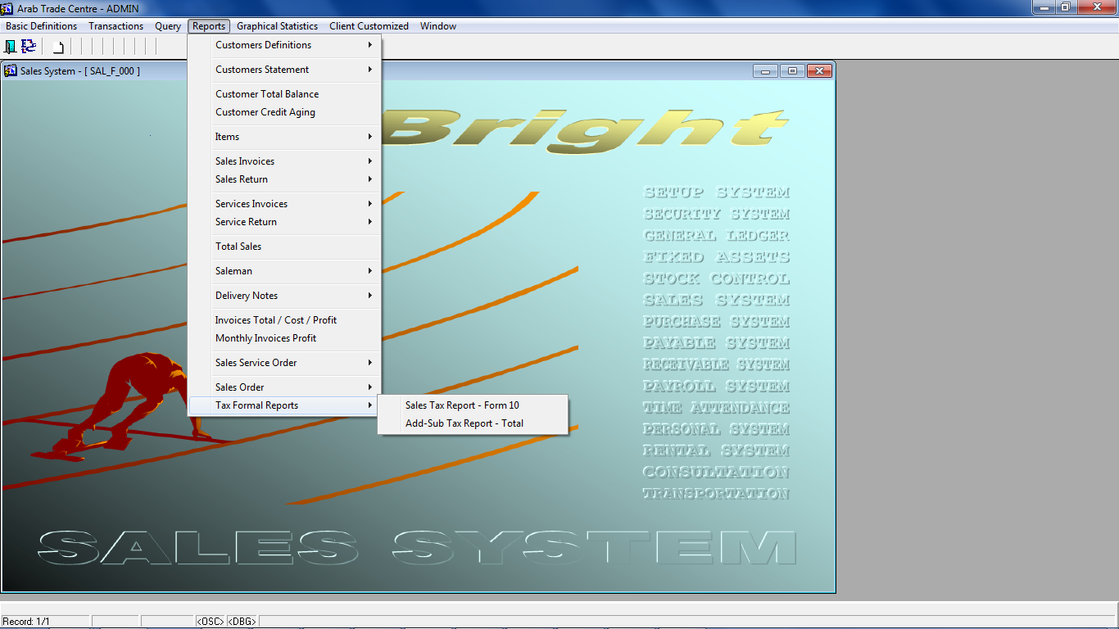

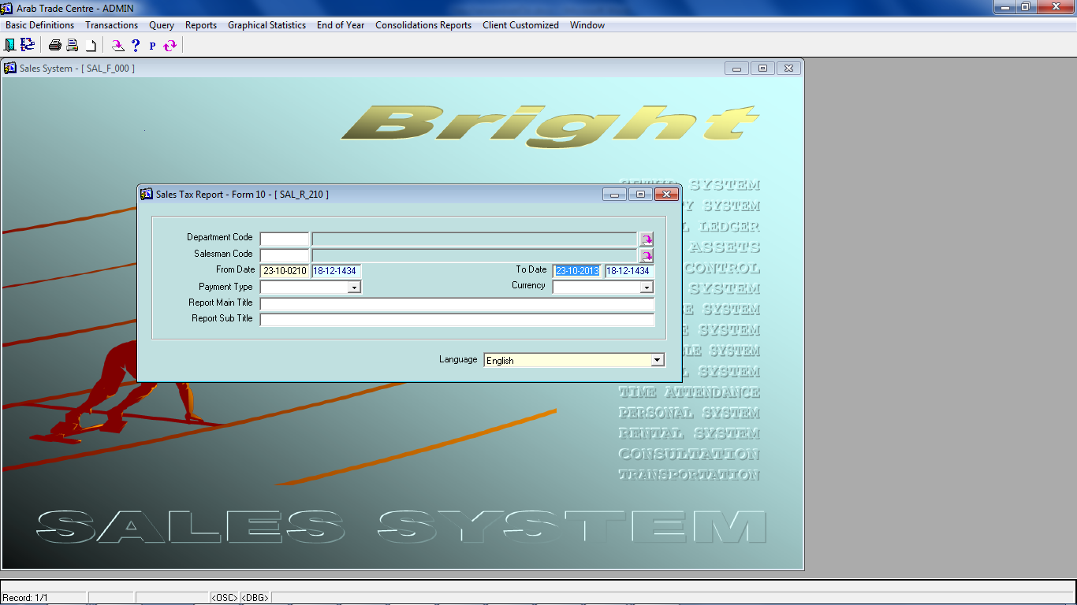

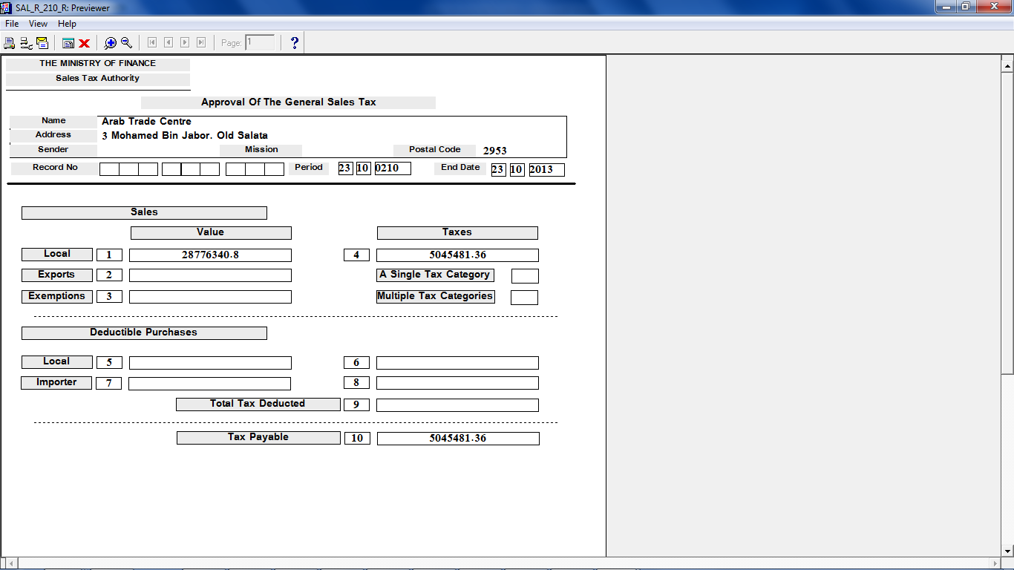 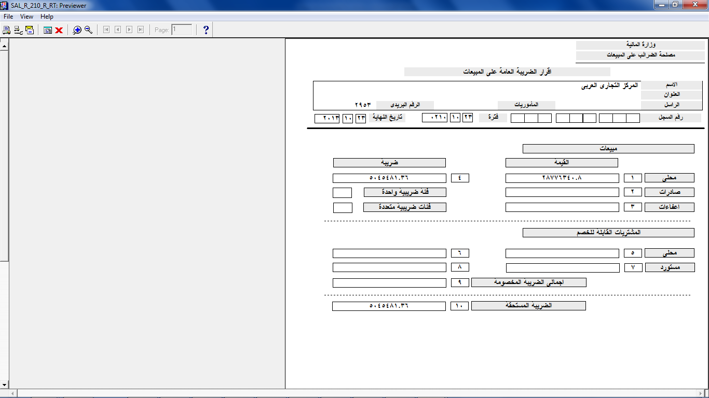

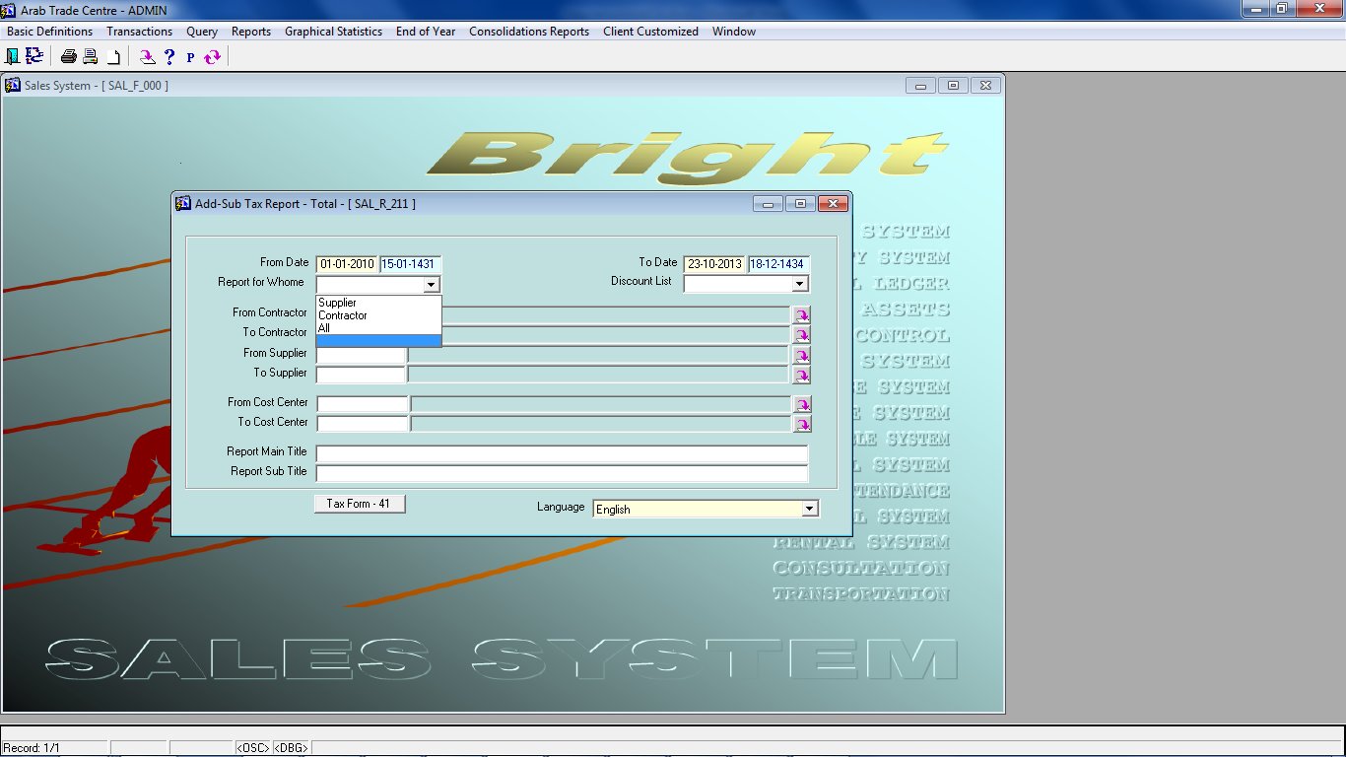

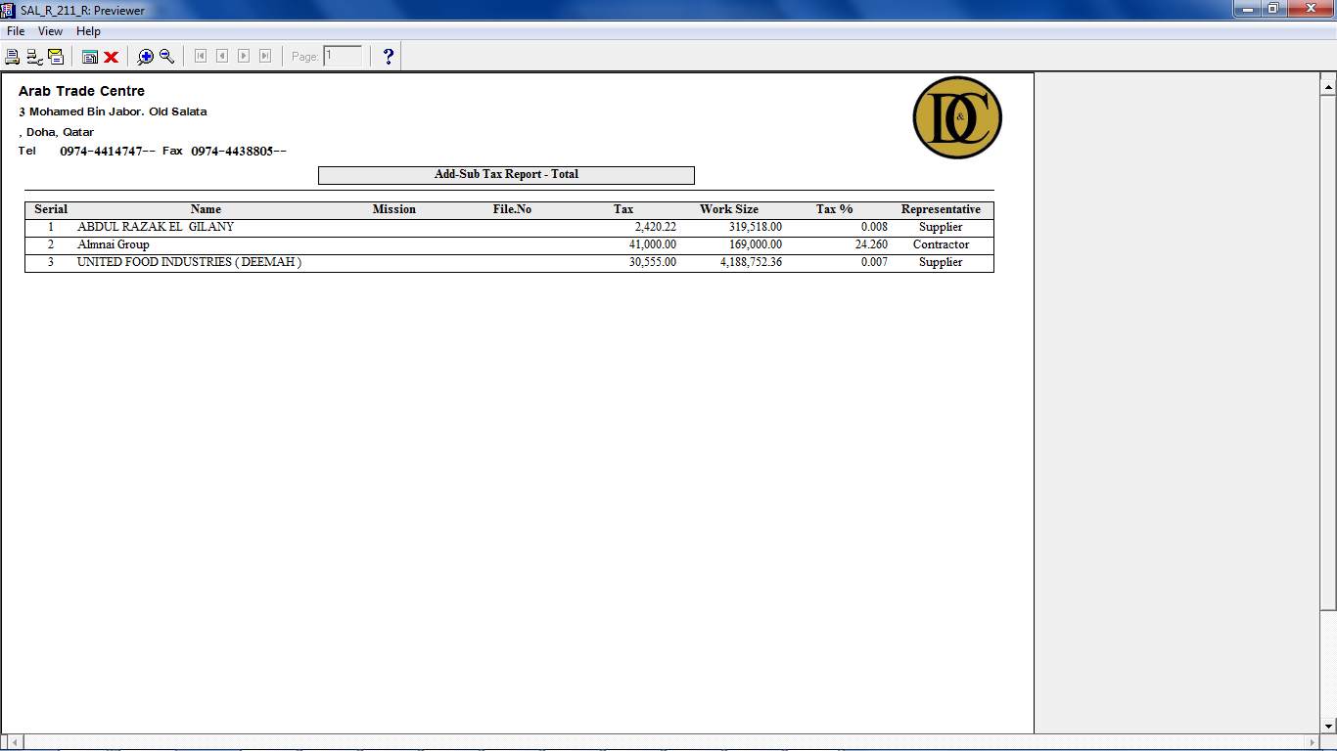

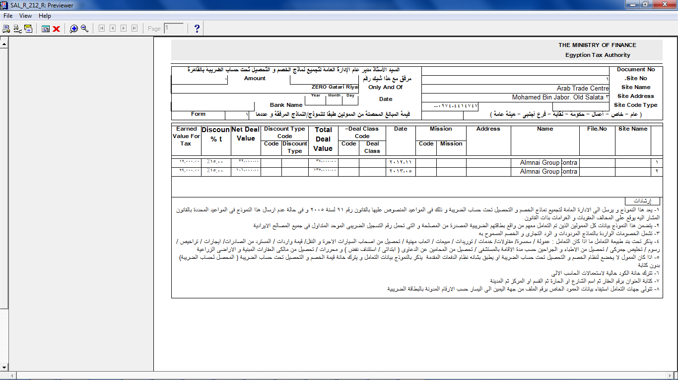

**Ready Mix Delivery Note :::**

I had added new parameter for "Ready Mix" ;if it has "True" , system will have sub-menu for Ready Mix Data as you shown below .

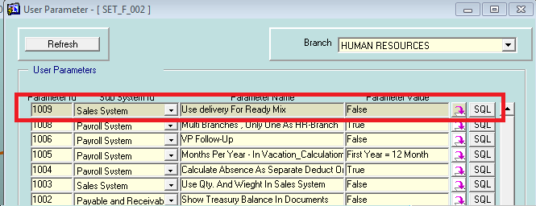

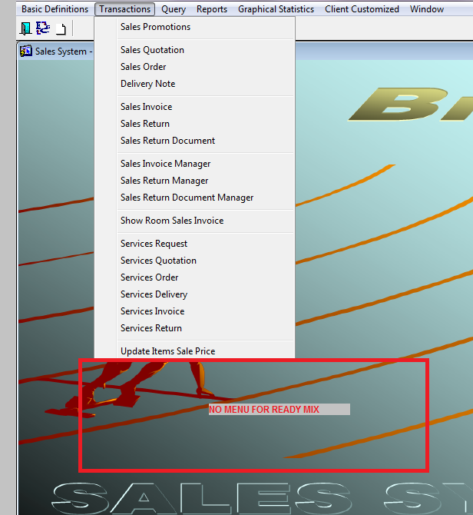

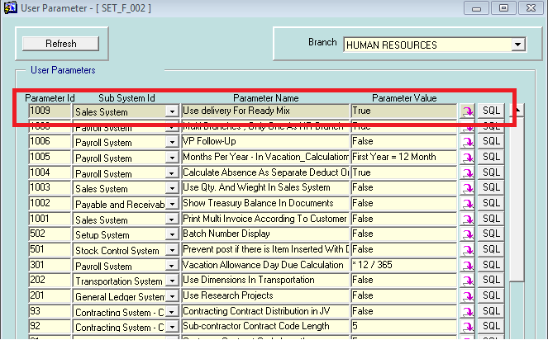

In drivers' data , you can assign employee , or not .

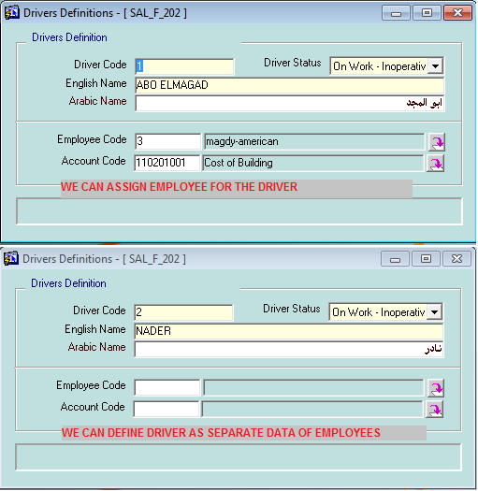

In cars' data , you can define more details of the car.

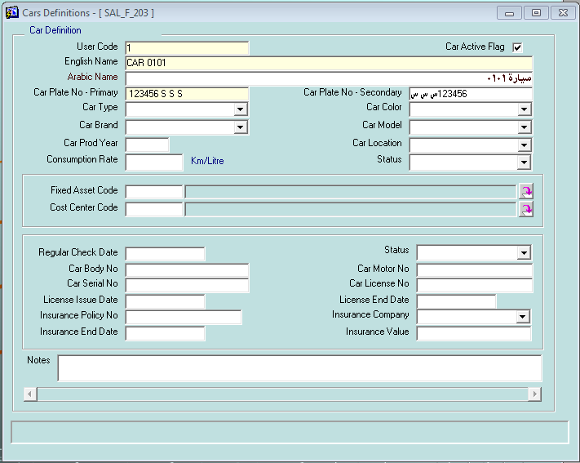

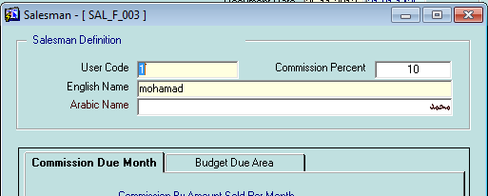

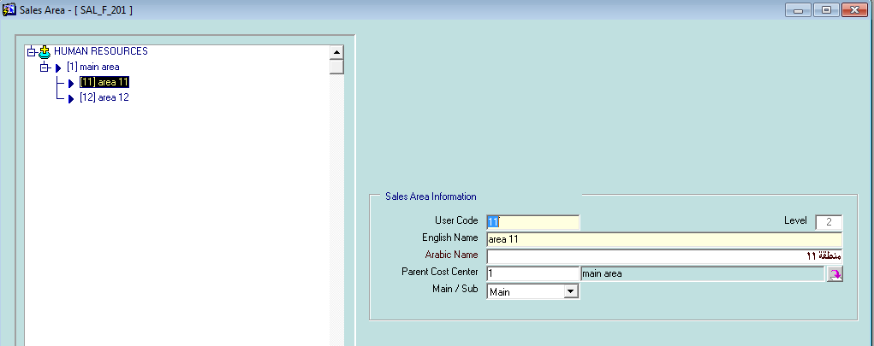

Now , the delivery for Ready Mix , will have details about (car , driver , salesman , sales area , time , QTY) as you ask in the main requirement.

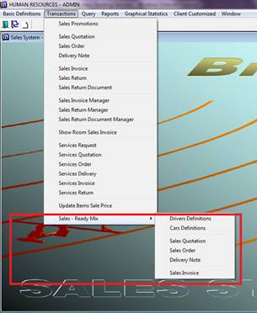

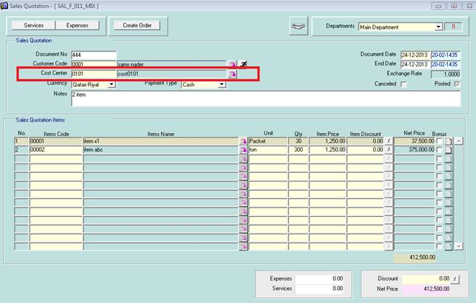

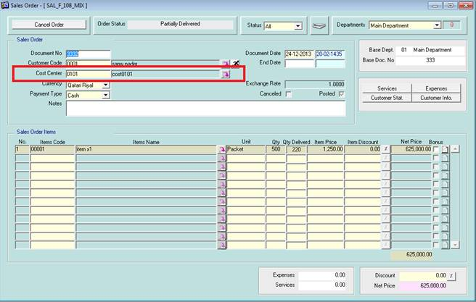

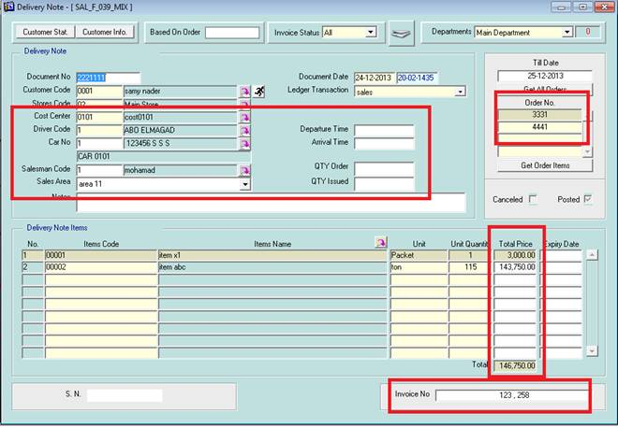

**ثانيا : عند عمل فاتورة المبيعات يتم اختيار امر البيع ومن ثم يمكن اختيار الديلفرى نوت المسلمة بناءا على امر البيع لان فاتورة المبيعات تكون على امر المبيعات فقط**

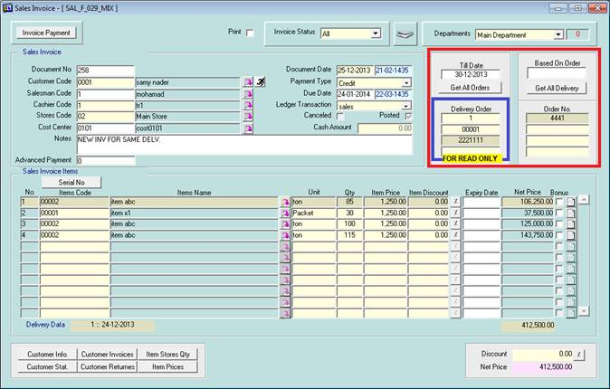

**READY MIX MODULE**

Herewith all modified forms/reports related to READY-MIX , and they look like the following snapshots……

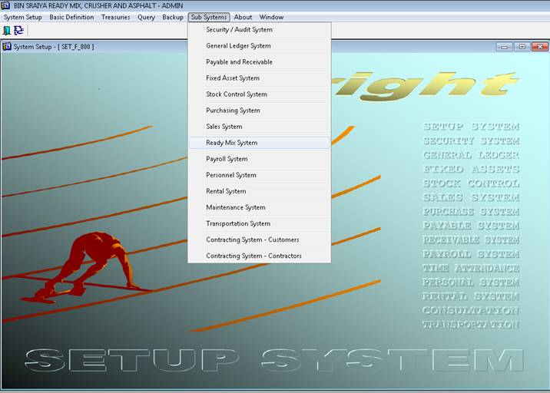

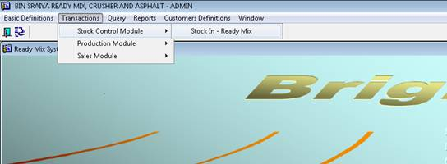

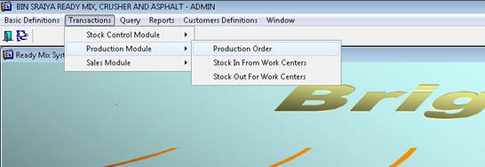

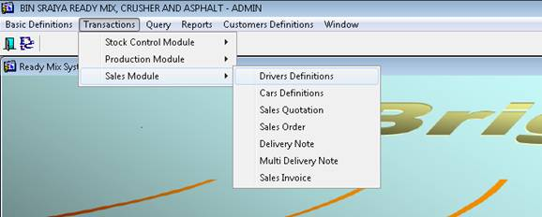

**Stock Control Module**

STOCK IN – READY MIX

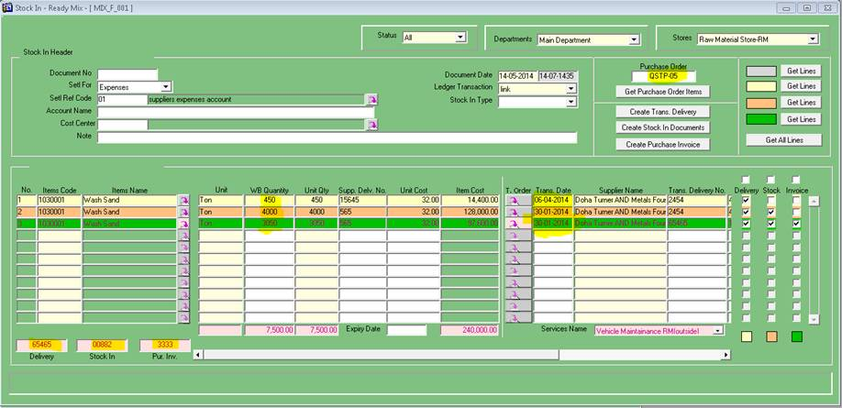

As it was changed completely, I will list a brief on using it:

* Select Purchase order >> get its items
* Edit the getting lines
  + add more details like supplier delivery no , transportation data , staying qty as it is / reduce qty as coming qty.
  + to add line has same item but different details , kindly press F4 , to get all details of the purchase order even not seeing , then edit what do you need.
  + At any time qty > order's qty , system will alert user by

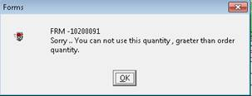

* After entering any number of records, user simply can check record to go as transportation delivery, then click on button "Create Trans. Delivery", the related delivery no. will be get in the bottom
* Any record has gone as transportation delivery ,can be checked to create stock in document, simply check them , click on button "Create Stock In Documents", the related stock in document no. will be get in the bottom
* Any record has gone as stock in document ,can be checked to create purchase invoice , simply check them , click on button "Create Purchase Invoice", the related invoice no. will be get in the bottom
* As shown in colors , user can get lines of any doing action , or get all .
* Also ,as shown in the form user can select all given lines by check the top check box of any action.
* By this changes in the form , user can know by his eyes the amount of record need to make stock in / invoice …. And so on
* All created stock in / invoice was not confirmed yet.
* All create transportation delivery was confirmed (as it is not affect on any balance)
* User can't delete any record has at least checked as gone to delivery.
* User can't update/delete any record has checked as gone to stock in document , and of course if checked as gone to purchase invoice.

PURCHASE DELIVERY (3 LINES)

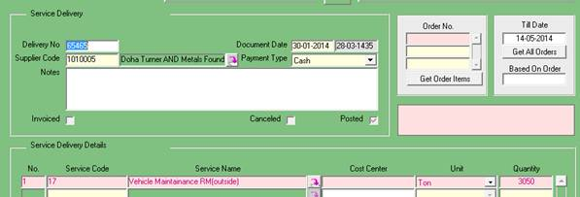

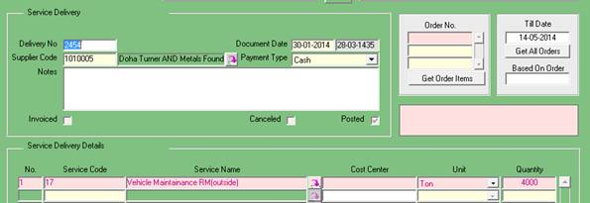

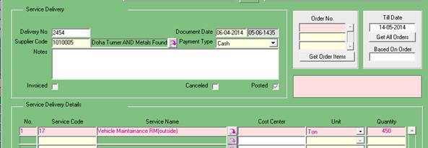

STOCK IN (2 LINES)

4000 + 3050 = 7050

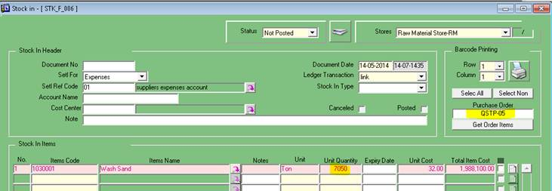

PURCHASE INVOICE (1 LINE)

3050 ONLY

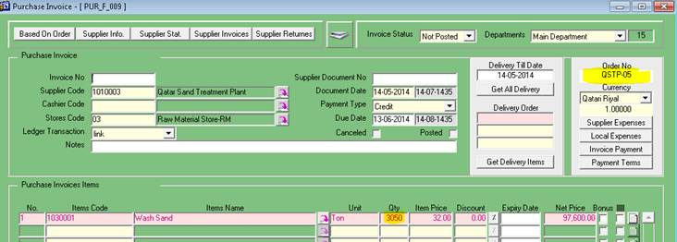

**Production Module**

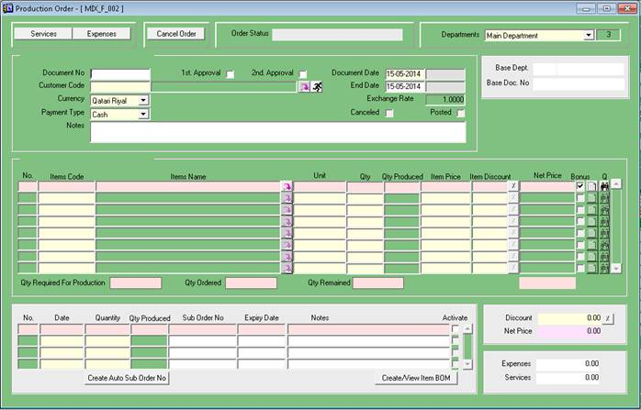

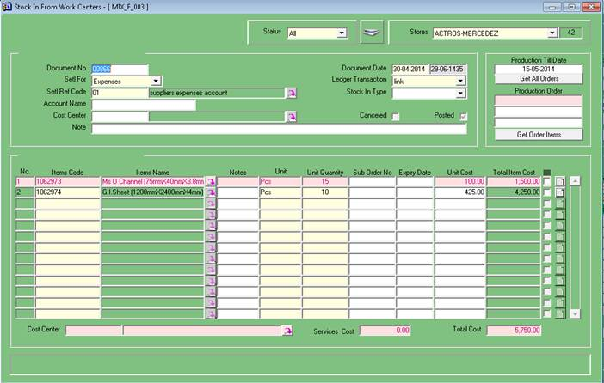

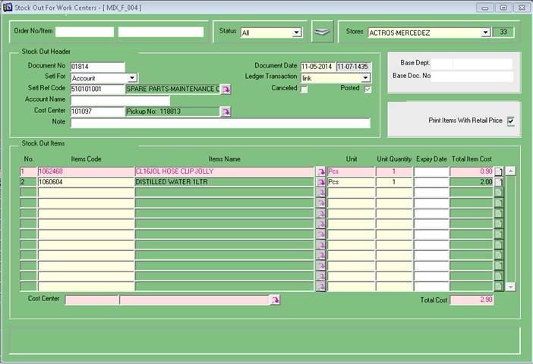

**Sales Module**

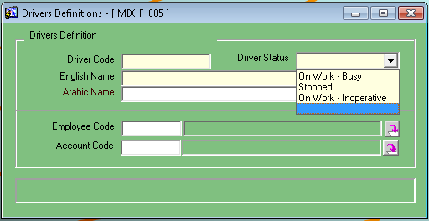

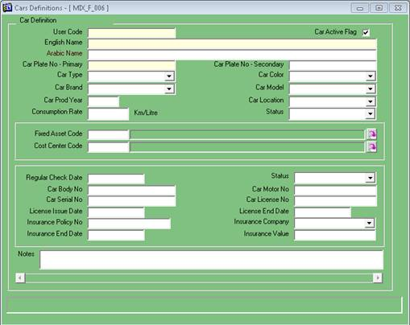

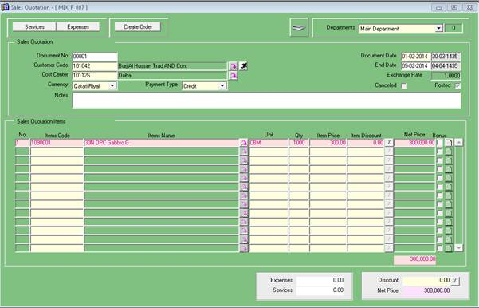

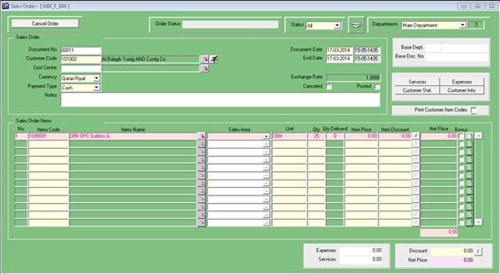

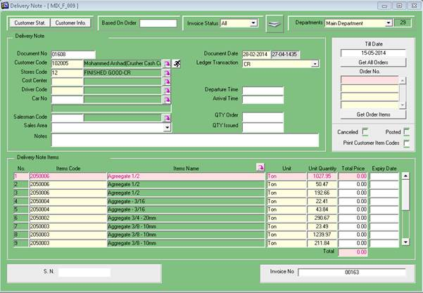

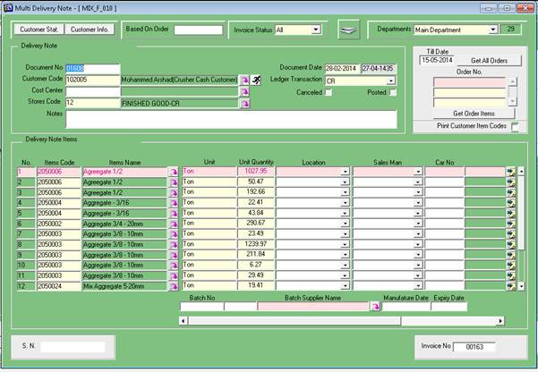

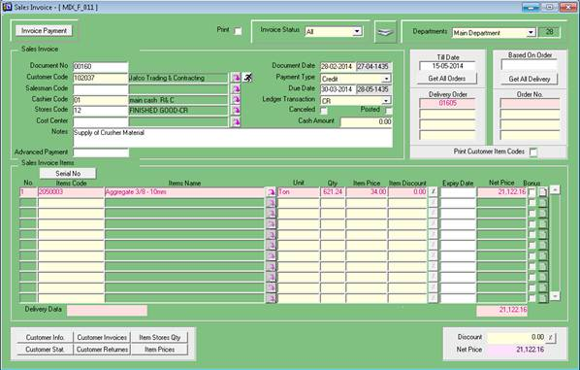

**Purcahse Add-on:**

**PUR_R_025         SCREEN**

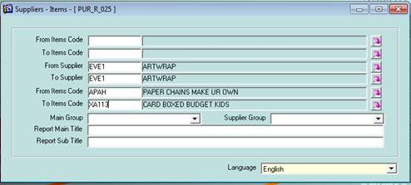

**PUR_R_023_R  ADD UNIT PRICE BY QR. According to currency of supplier**

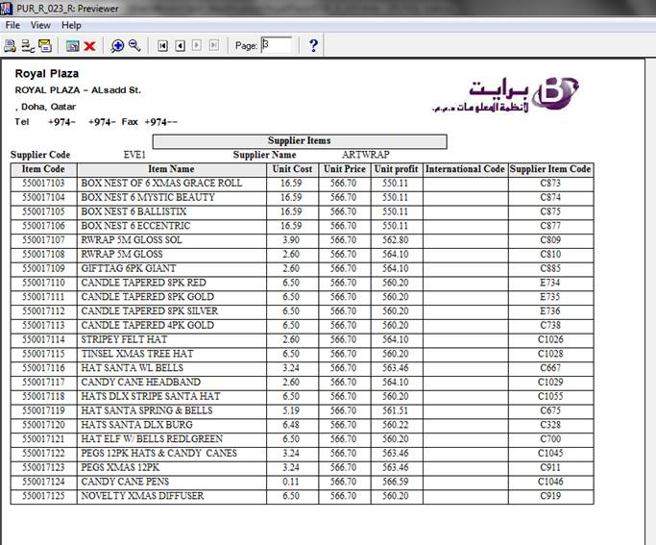

**Ready mix in STOCK / PURCHASE  module**

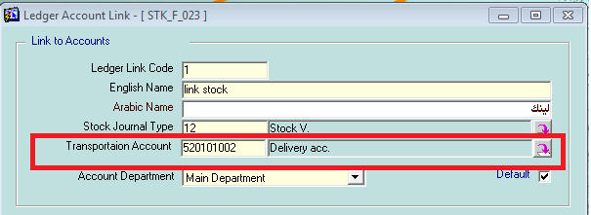

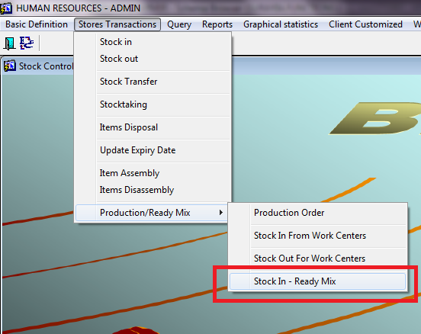

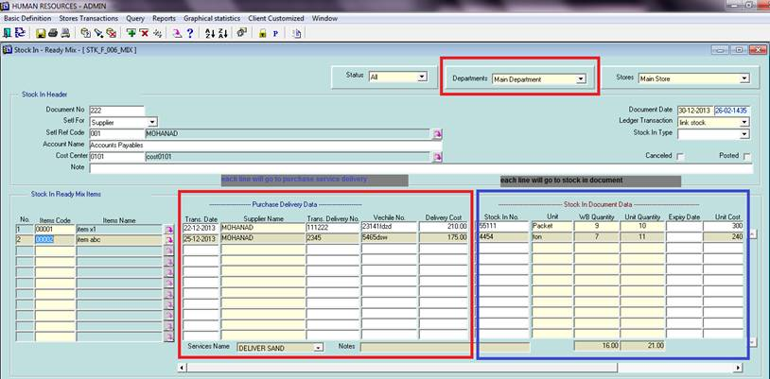

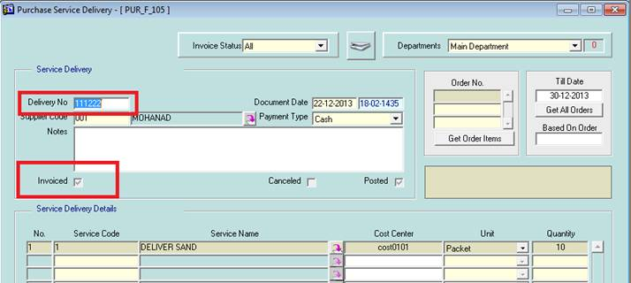

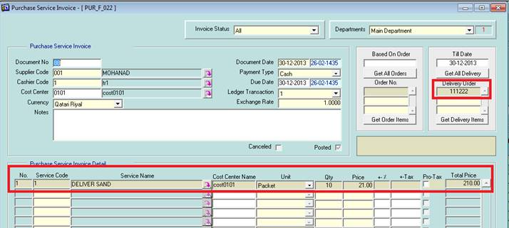

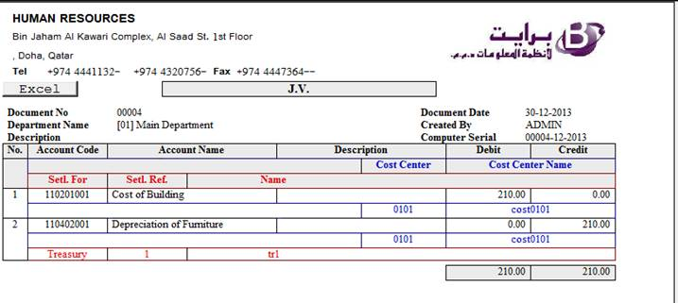

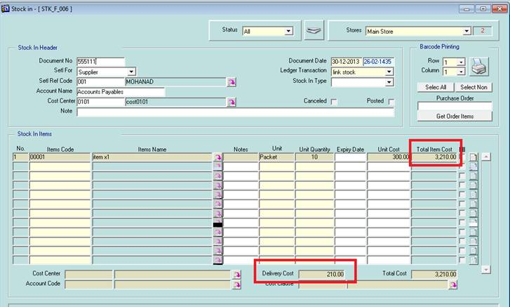

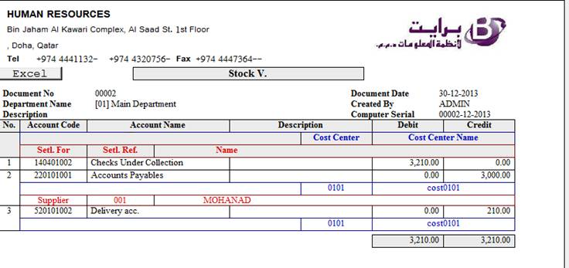

**Payroll-Personnel-HR Add-on:**

* Customize payroll version to be one of 4 choices:

Qatar, Egypt, KSA, Dubai .

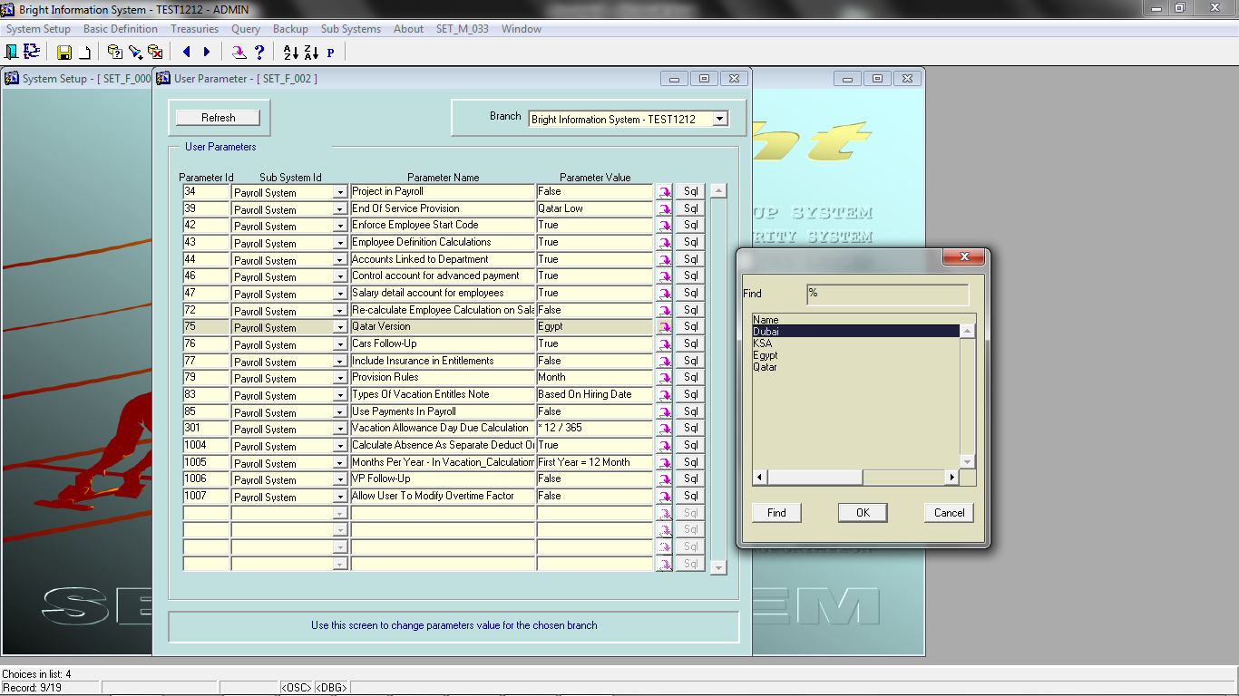

* Assign manager for each project , when change project , manager changed directly

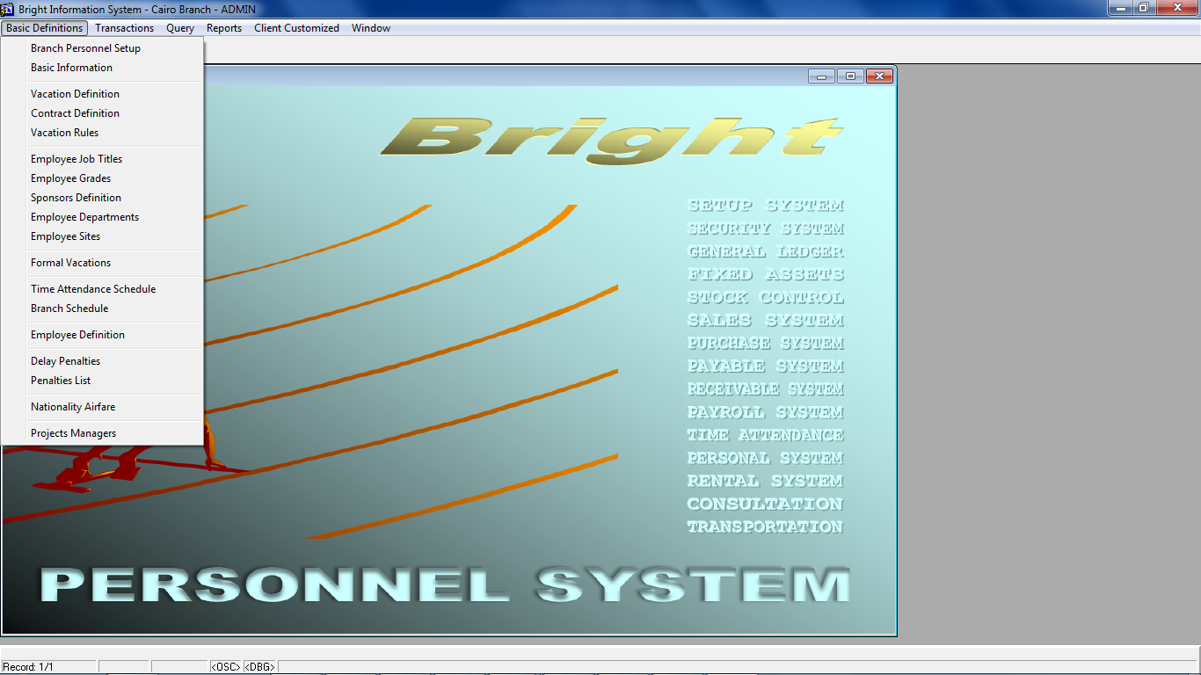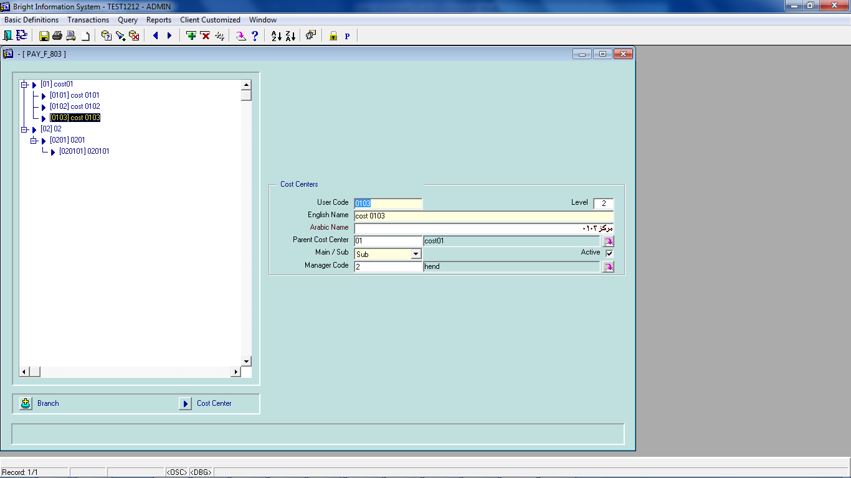

* Change cost center of an employee's deffination , to last cost center was assigned to him in time sheet (after user confirm this update)

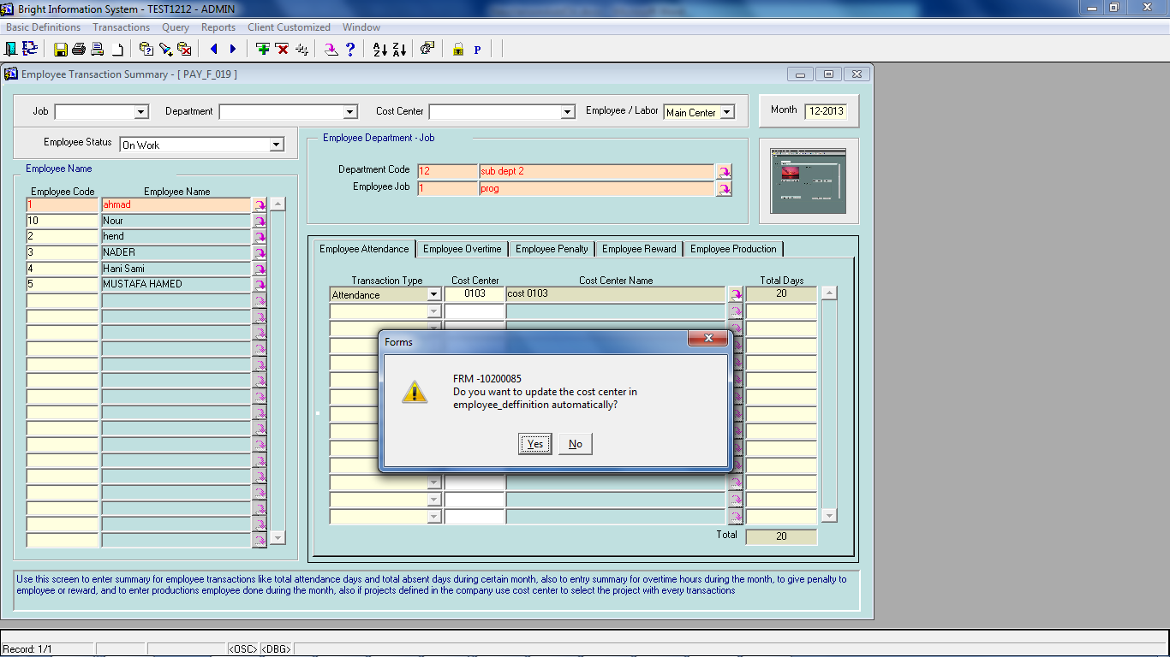

* Return from suspend affect on salary on such month not on all preparation

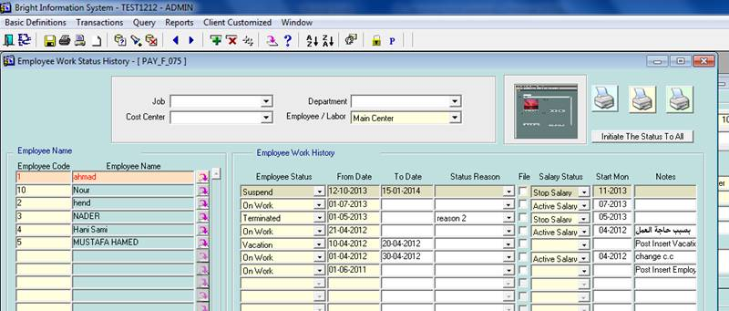

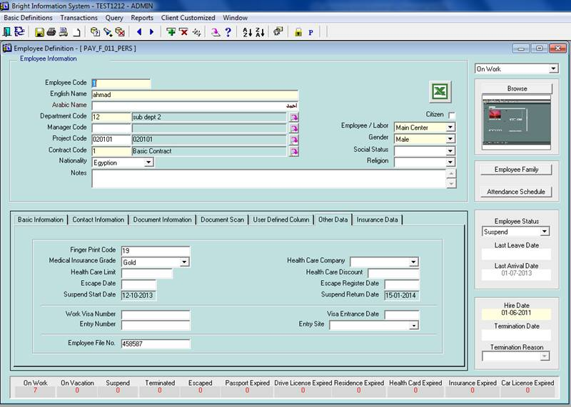

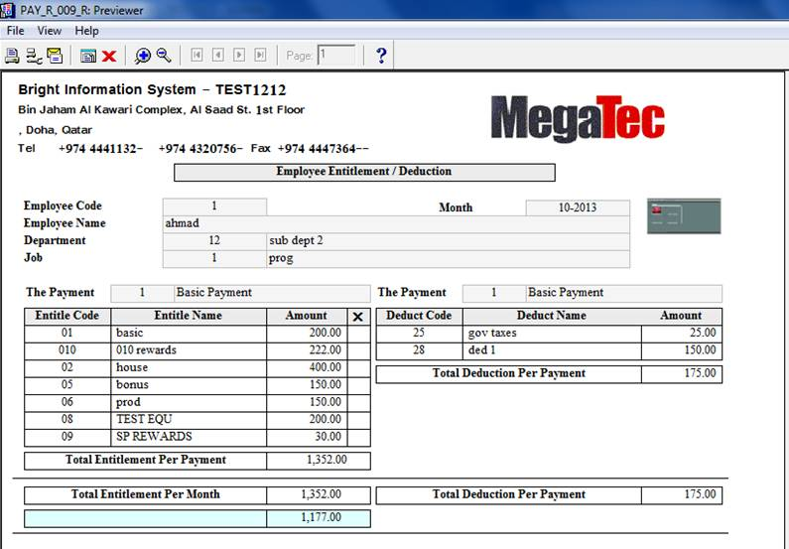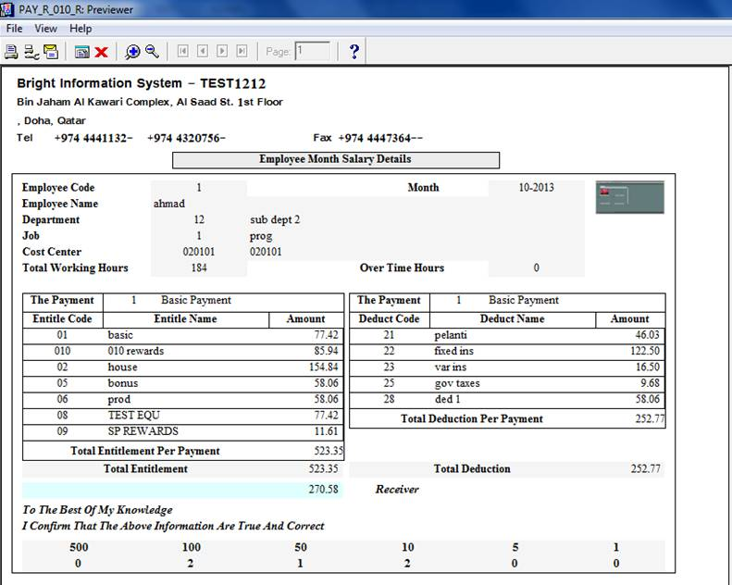

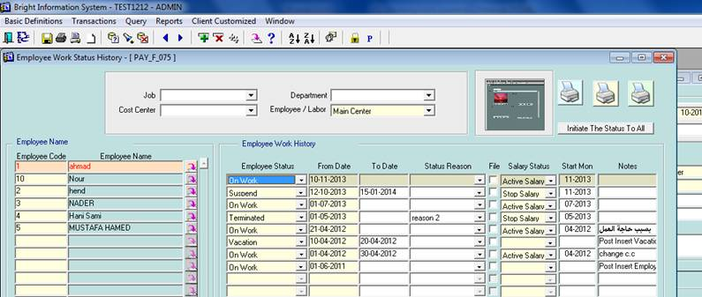

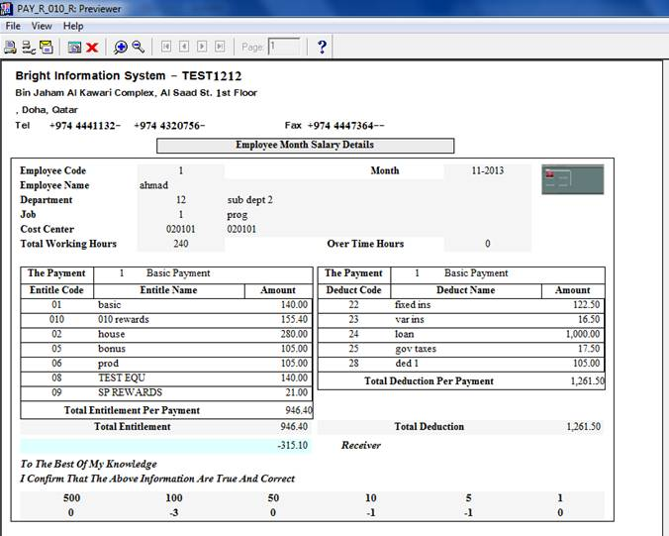

* In employee query form , user has option "sort for all the fields "

**In this screen to sort by any field , you simply double click this field , sooo easy**

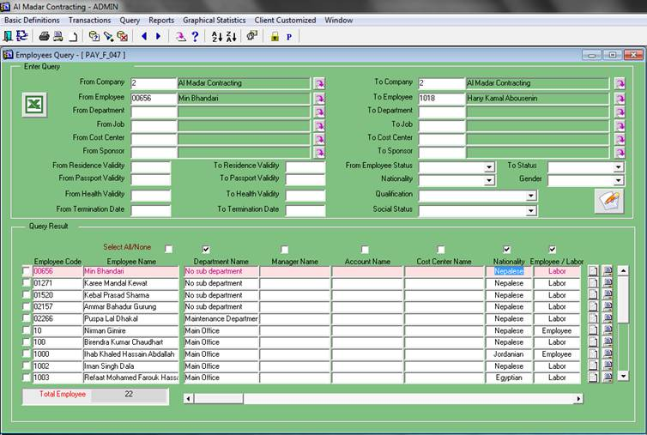

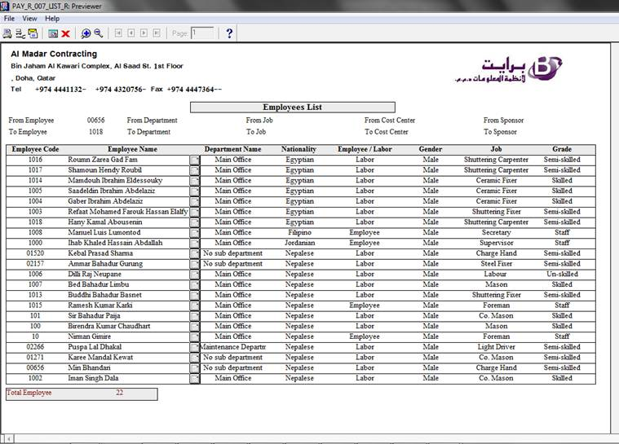

* In employee query form , user has option "filter employees to select which employees to print"

**In this screen to, you simply check which employee(s) will be printed , then you will get them only  , sooo easy**

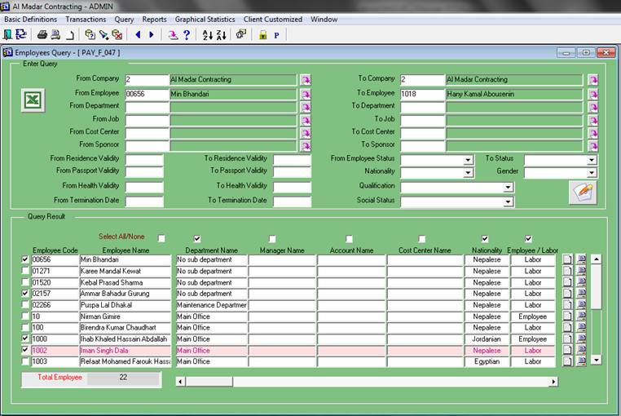

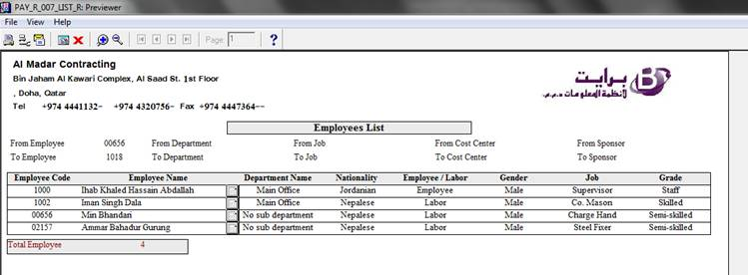

* We need to track the shifting dates of employees. The ERP must provide a history for the shifting of employees.

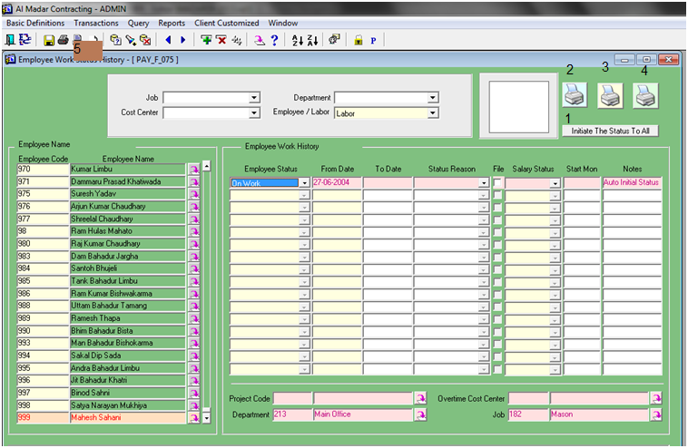

In this screen , system can archive Movements for all of the following:

**Project (Main and Over Time)**

**Department**

**Job**

Button 1 : System can initiate these data for 'ON-WORK' status to the current ones

Button 2 : System print history of Projects (Cost Centers)

Button 3 : System print history of Departments

Button 4 : System print history of Jobs

Button 5 : System print total history of such employee

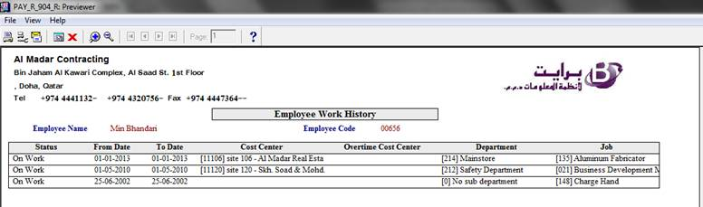

* **Multi Branch , Only One for HR**

Now , our Bright' Application has new feature which allow **user to define all employees in one branch and set this branch as HR branch , all other branches will be defined as sub-departments in HR branch**

Few steps lead us to required target:

* Set user parameter 1008 to true in HR branch
* Check the HR branch as "Main HR Branch" in branches' form
* Mapping Accounts in HR to Accounts  in other branches
* Mapping Cost Centers in HR to Cost Centers  in other branches
* Mapping sub-department  in HR to branches
* Define new type in **Legal Person Types** as **'Employees in HR'**
* Mapping Employees in HR to Legal Persons other branches
* Use new **Post Salary To GL** form

Some snapshot to illustrate these steps as we will show hereunder.

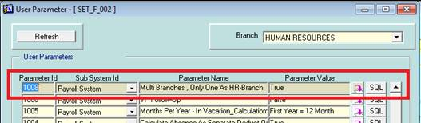

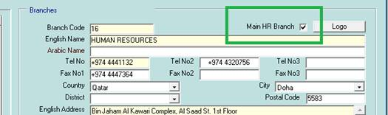

Only one branch can be HR branch

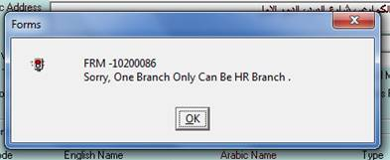

User will make mapping for the following (hint: for other branches this mapping button is disabled )

* **Mapping Accounts in HR to Accounts  in other branches**
* 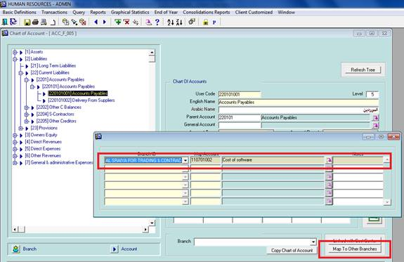
* 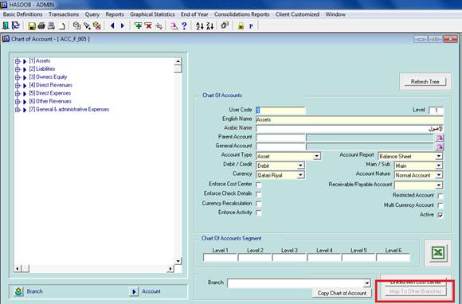
* **Mapping Cost Centers in HR to Cost Centers  in other branches**
* 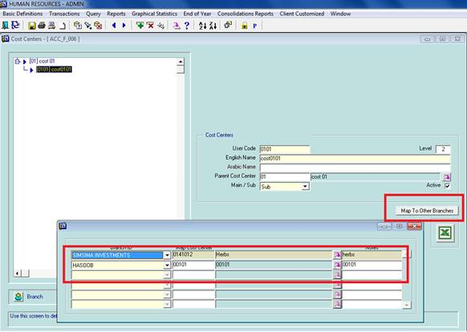
* 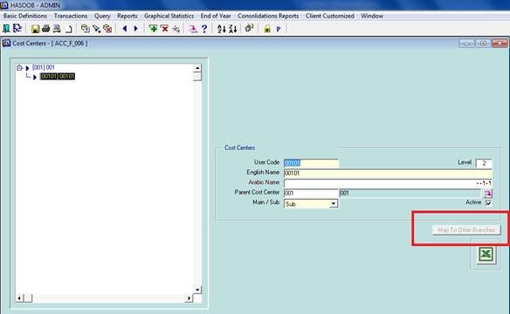
* **Mapping sub-department  in HR to branches**
* 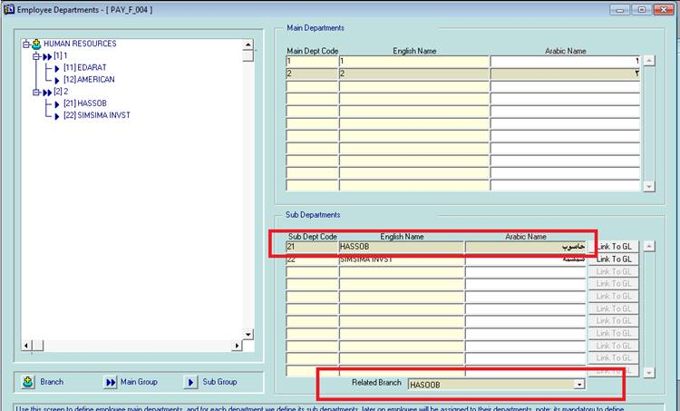
* **Mapping Employees in HR to Legal Persons other branches**
* Define new type in **Legal Person Types** as **'Employees in HR'**
* 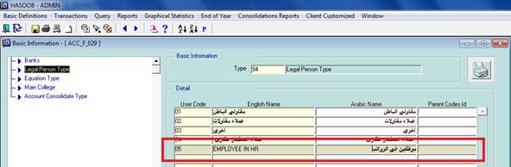
* 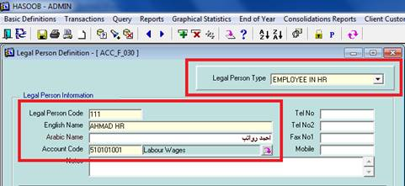
* 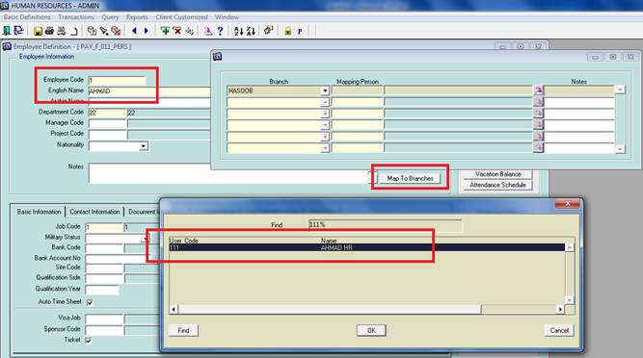
* **In other branches user doesn't have any definition of employees, salary, attendance …**
* 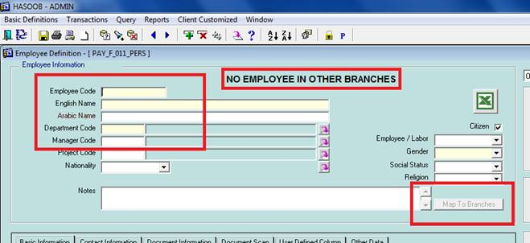
* **In Post Salary To GL Form , we will have** 
  1. a payroll department to map required branch (get its salary)
  2. a GL department of mapped branch to send journal to it
* 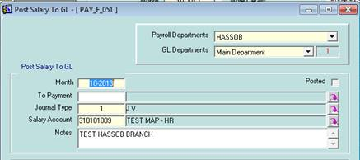
* Here I take an example of salary in HR branch , related to 3 other branches and the outgoing GL-Journals as you see
* 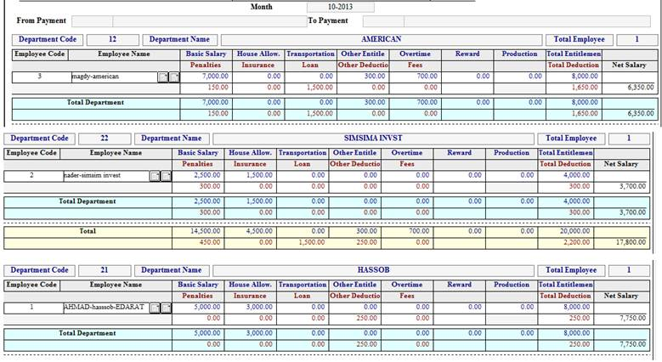
* 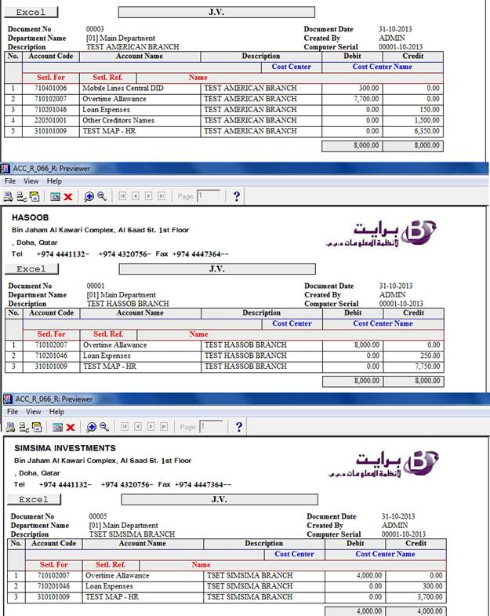

**Manage Job To Be Payroll/Non-Payroll Job**

This solution is more fixable and valid for any job on the branch , to hide salary 'money's data' from any user you will do the following :

* Define new job for  NON_PAYROLL_USER
* Set check box "Non Payroll Job" to "TRUE"
* Save this job
* Define users which have this new job
* Enjoy the test to see the effect of this check

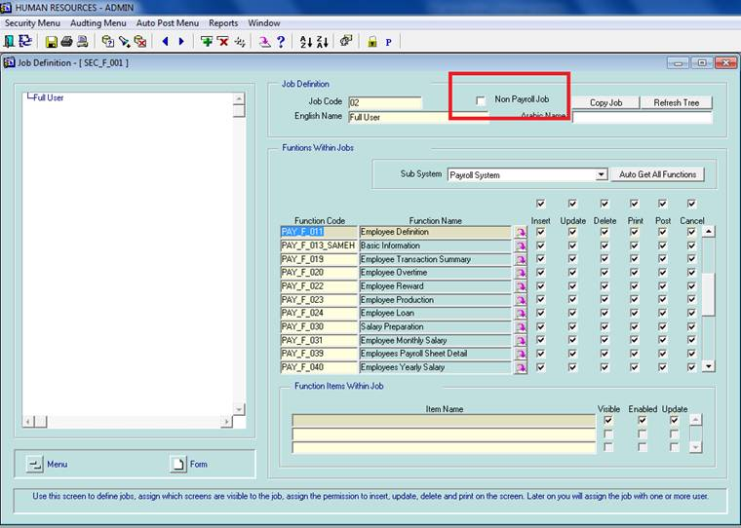

Example of PAYROLL_JOB form layout >>>

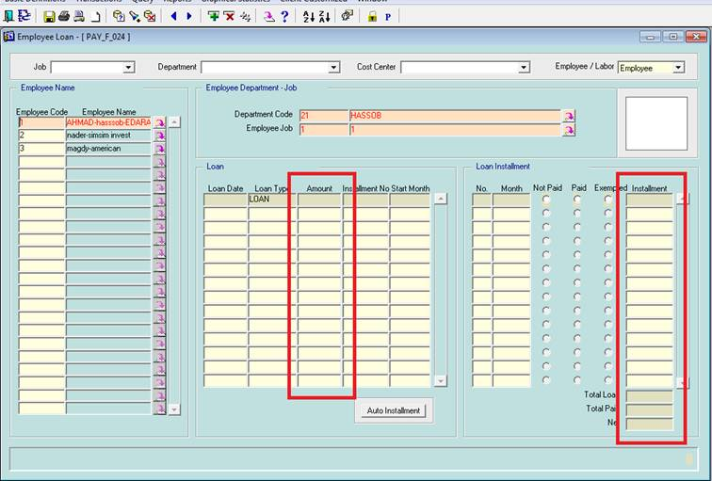

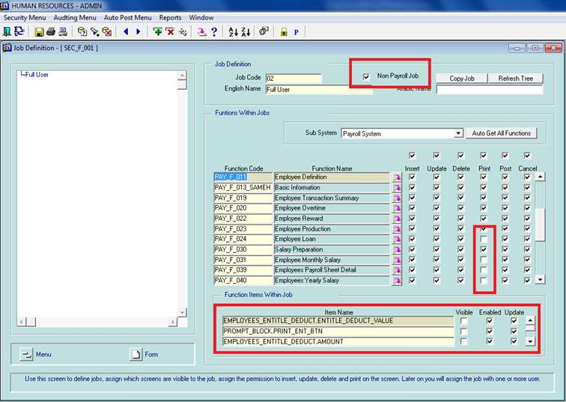

Example of NON_PAYROLL_JOB form layout >>>

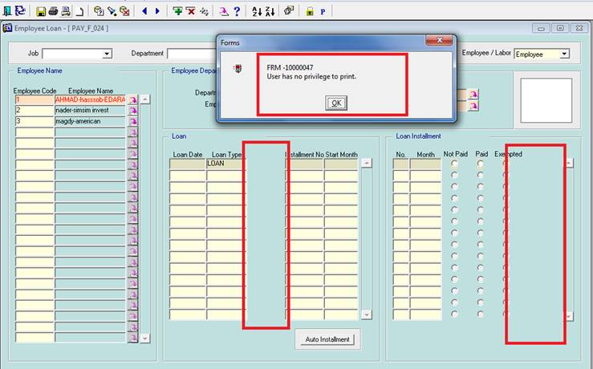

* **Day of provision differs between EOS and other provision**

**In calculation**, day value of provision will differ between day of EOS provision and day of other provision .

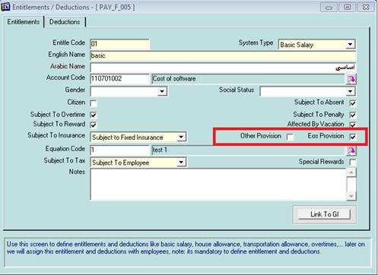

* **Normal penalty differs of late penalty**

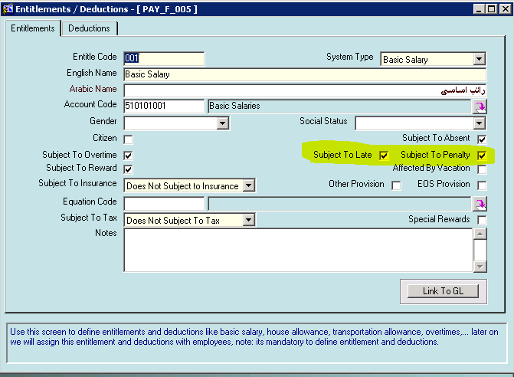

Hours means late (rate * hour of subject to late), days means normal penalty (rate * day of subject to penalty), and food means (rate * no.of absence days)

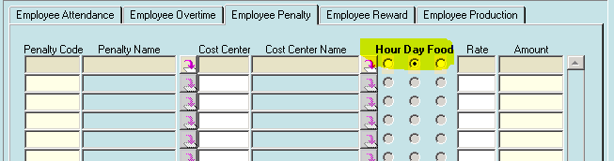

* **Minimum Overtime Rate (Qr. 6) for Payroll System.**

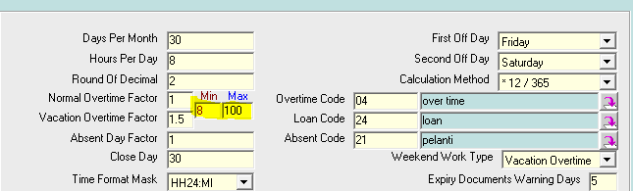

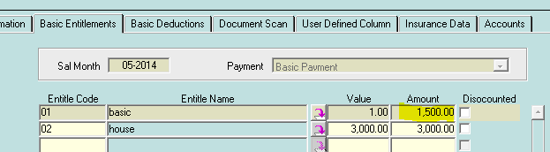

**1500/30/8 = 6.25**

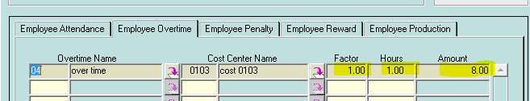

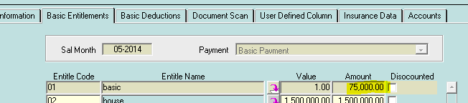

**75000/30/8=312.5**

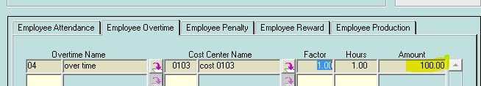

* **System apply the law for penalty , hajj vacation , sick vacation as in QATAR law which include …**
  + Define a list of all Violations
  + Define a list of penalties for each Violation
  + Penalty may be just a written letter , deduction as part of day from salary , deduction as hours from salary , or collection of all of them
  + Penalty has an order from 1 to 4 , and any repeat over 4 will be taken as 4th one
* System validate that .. max of 5 days only must be deducted from any employee per month
* System validate that hajj vacation should be taken once per each employee working years , and for max 20 days
* System validate that .. sick vacation has special rules (first 14 days will be full paid days , next 28 days will be half paid days , next days will be full deducted days )

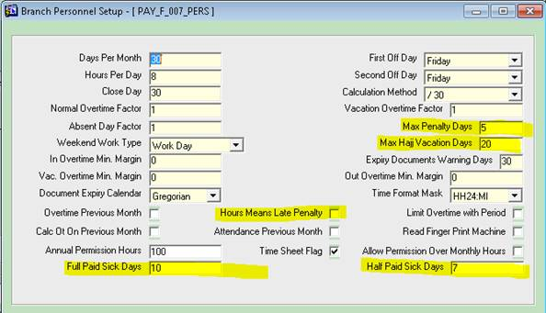

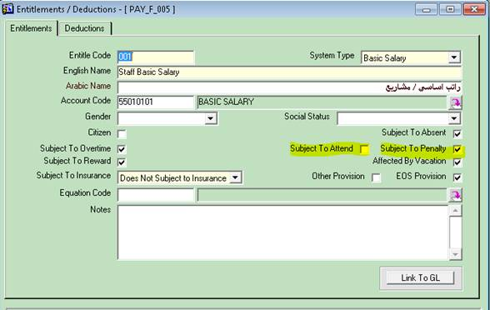

Any penalty select to make effect on others , will be shown in different color in all forms  as shown below .

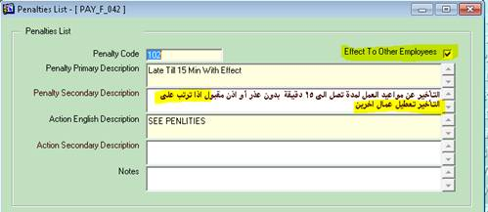

For similar violation minutes and order , user must select which one will be the default one

Otherwise , system will take less penalty to be applied.

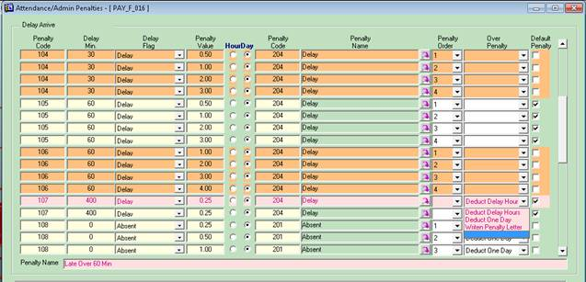

**If any violation need to a written letter , system will check the flag of written penalty for this employee in such month as shown below .**

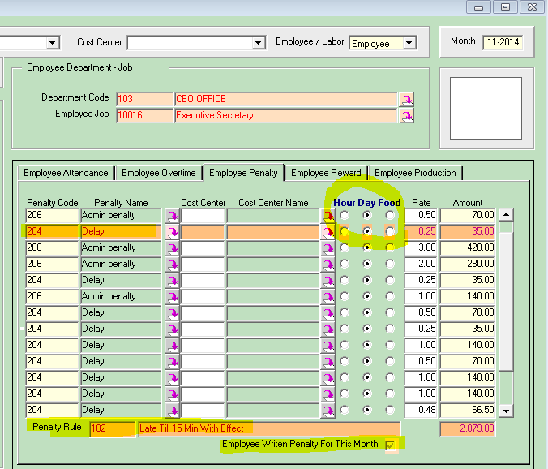

If user check " Hours Means Late Penalty" , then deduction will be taken from bands have " Subject To Attend " , otherwise deduction will be taken from bands have " Subject To Penalty" .

Food check , is an additive option to deduct [rate*(all absent days)]  .

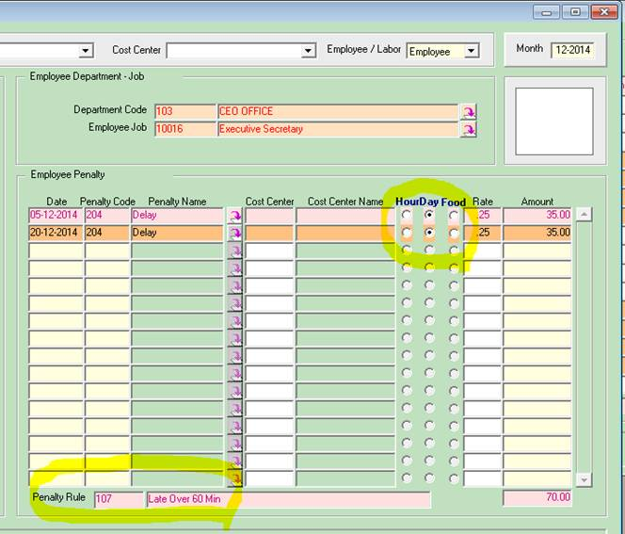

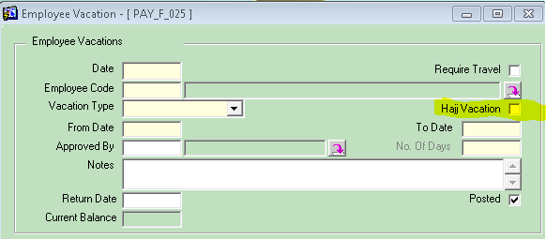

For sick vacation , no control while edit/confirm vacation (all action of deduction will be done while calculate salary)

For non paid vacation , user can sign it as hajj vacation  , and must be less than / equal hajj days in setup

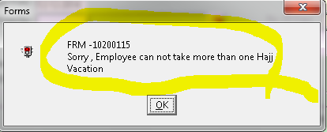

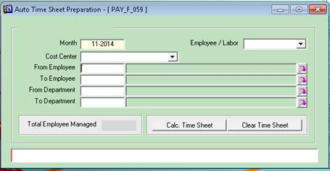

**If any violation need to a written letter , on clear time sheet , system will uncheck the flag of written penalty for this employee in such month .**

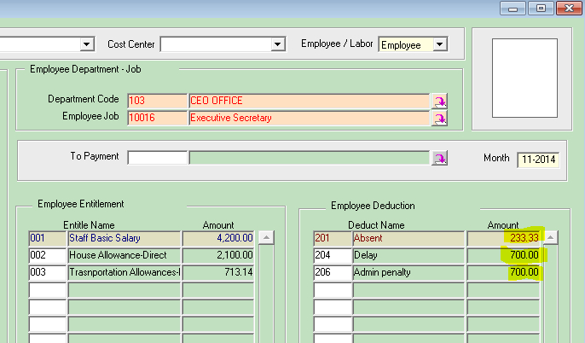

This employee has penalty over 5 days , but system deduct only **5 days for each penalty**

* **List of employees will be filtered by selected dept.**
* **System can ignore all penalty for such month**
* **System can make auto renew for someone's reach end of his contract**

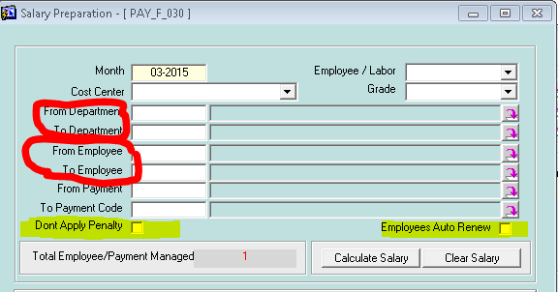

* **Use advanced setting for factory**

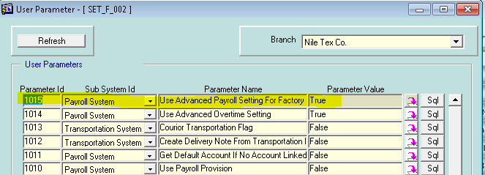

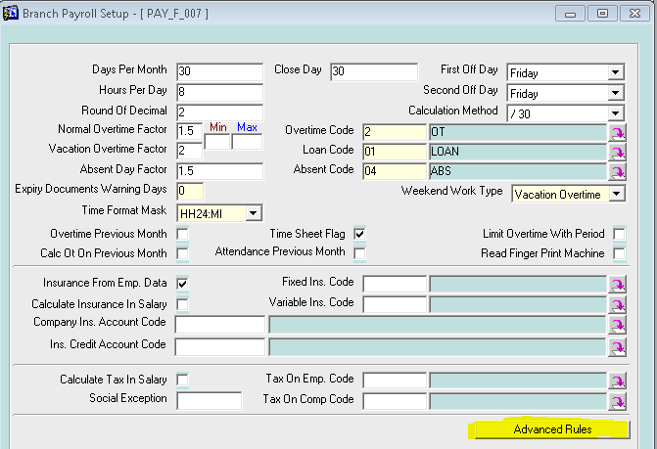

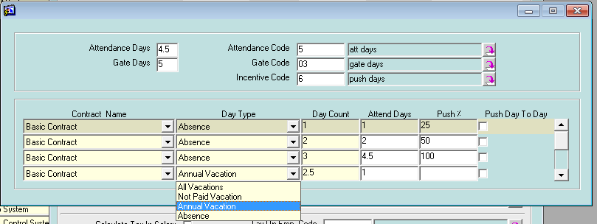

* **Use advanced setting for overtime**

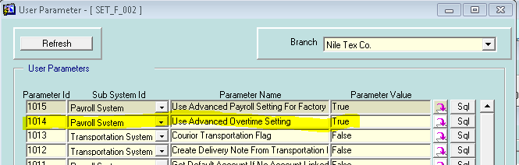

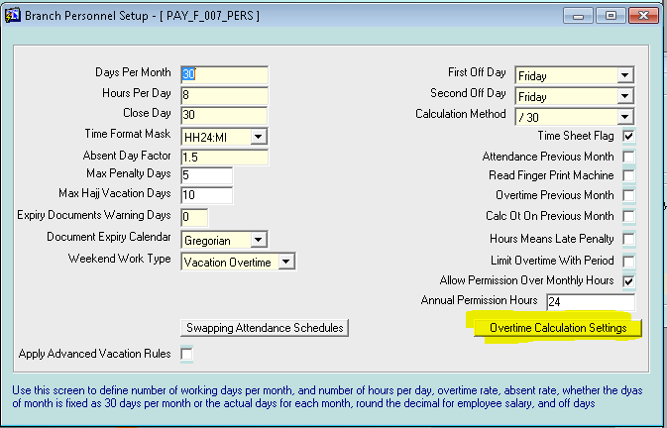

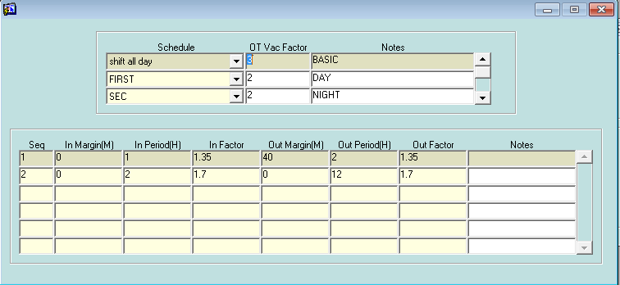

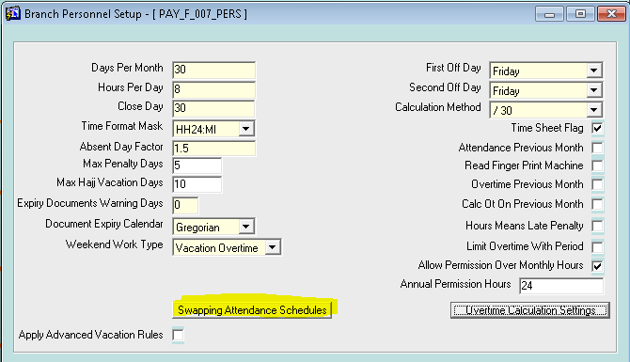

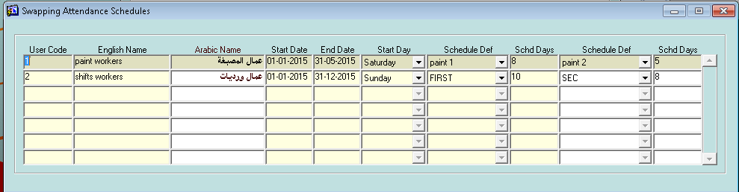

For each employee has special schedule , user must apply the swapping for him , by select the defined schedule

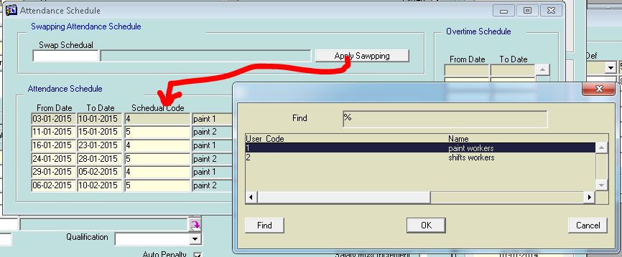

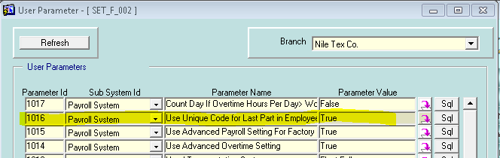

Code in employee can be unique , even he is employee , or labor .

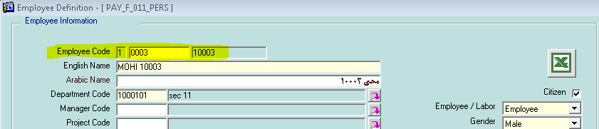

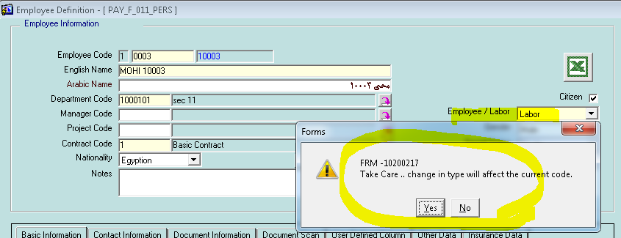

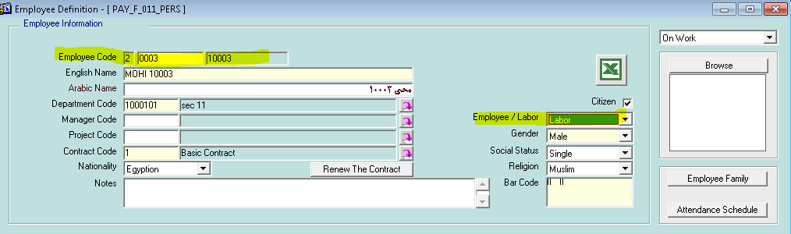

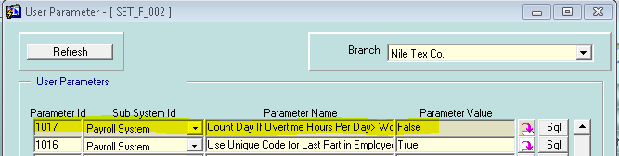

If overtime in vacation more than working hours , system will save 1 day in buffer to be used over vacation balance .

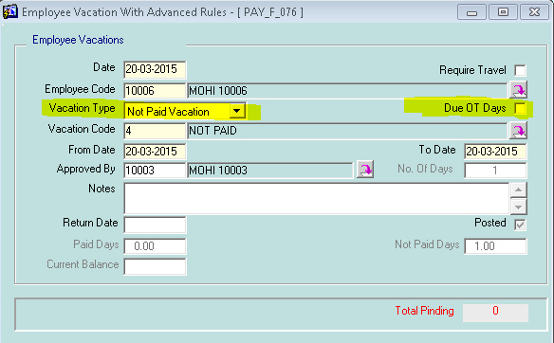

No deduction due this vacation when user check DUE OT DAYS , and employee already has days in buffer

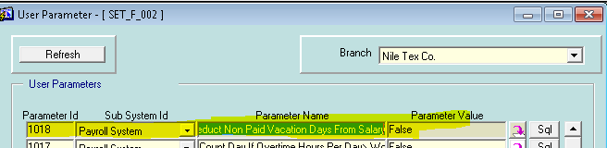

For Qatar version , when user select TRUE , any non paid vacation will be deducted from salary as whole period including weekly holiday , national vacation …

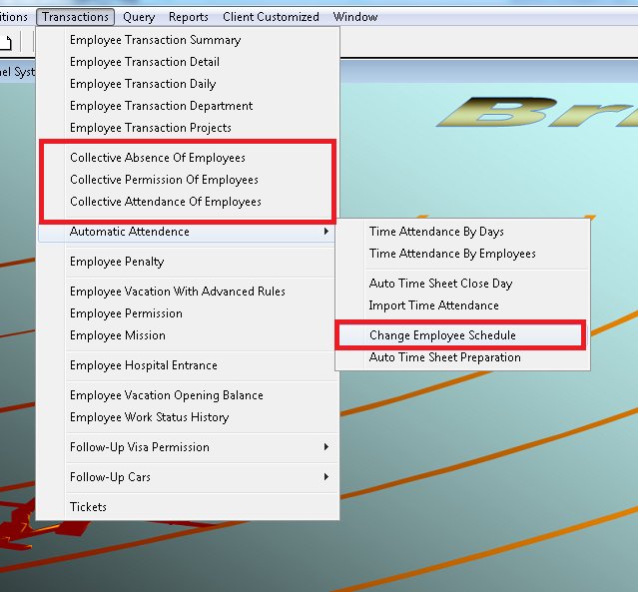

Now user can change schedule of employee in certain day , to avoid message of intersecting period in employee's schedule .

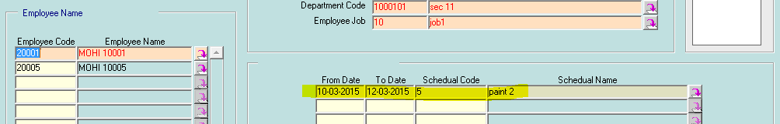

Now user can insert a collective (attendance , permission , absence ) for a group of employees for saving time

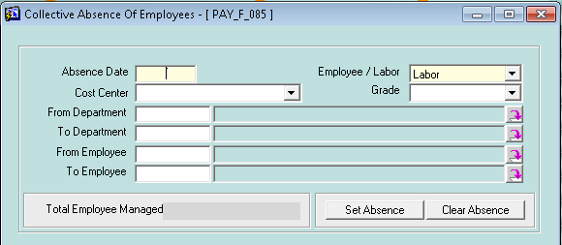

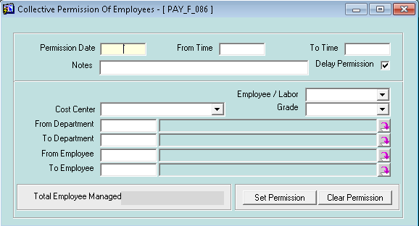

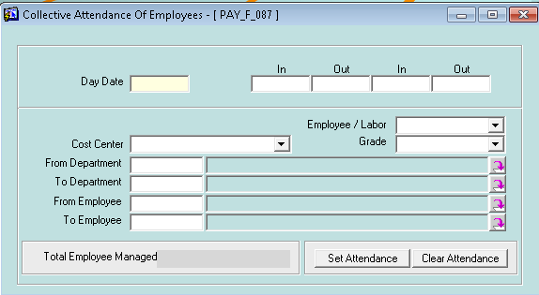

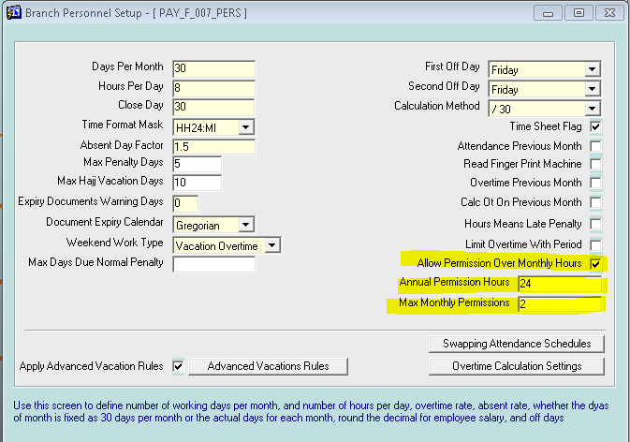

In past we control only the hours per month , per year … by divided hours per year /12

By insert value in MAX MONTHLY PERMISSIONS , Now we can control no. of permissions even the hours of month not taken yet.

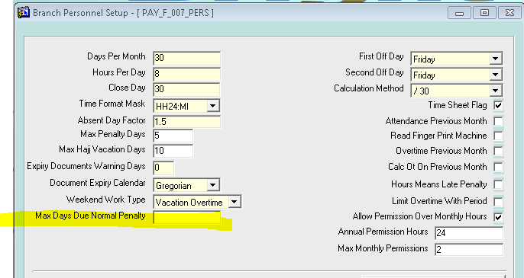

Now ,Penalty can be due bands subject to absence with limit in absence days .

Which mean , if days set to 5 and employee take 8 days as absence …

5 days will be taken from bands subject to absence

3 days will be taken from whole salary.

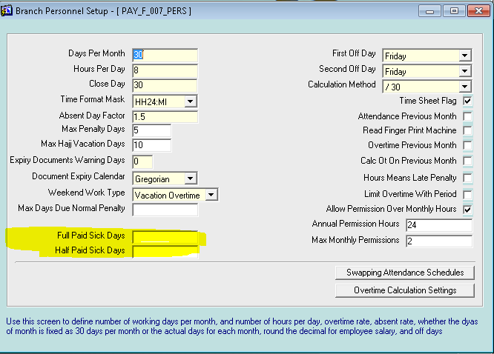

In Qatar version , user can control sick vacation , as listed in labor law

How many full paid days , half pad days ???

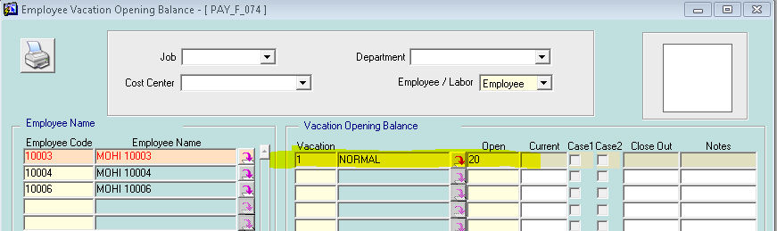

Now , user can insert open balance for any vacation name , manually

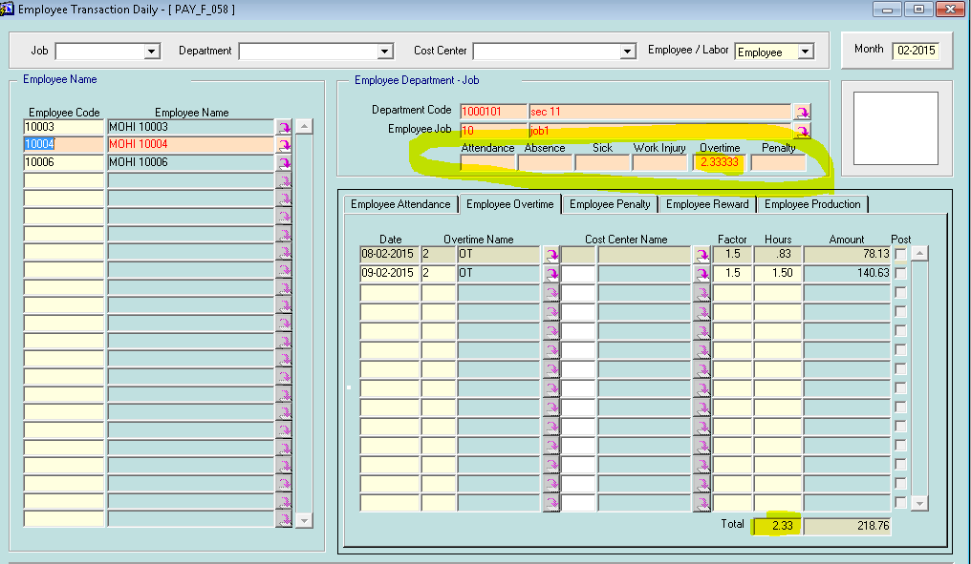

Summary fields per selected employee.

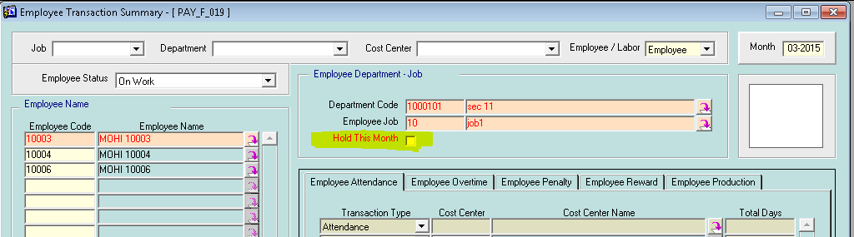

Hold month … will post amount of this (month,employee) to hold account in the Journal

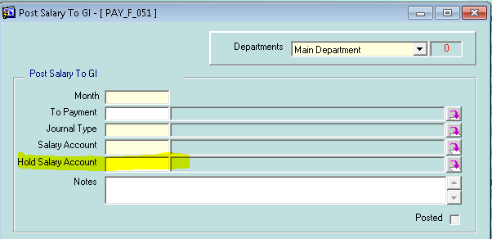

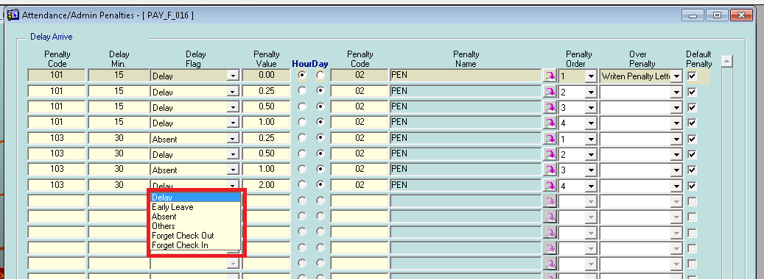

Now,penalty has type as forget check in / out , and for of AUTO TIME SHEET PREPARATION fix this issue .

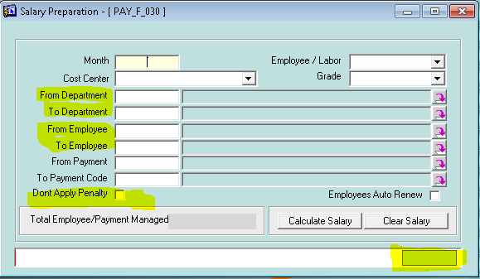

Now ,

form will display employee code in the box in bottom , for fast fix in any error.

User will select departments >> employees filtered by selected dept.

User can ignore penalties at any month , based on company's rule.

Add **A3 paper size** form salary details .

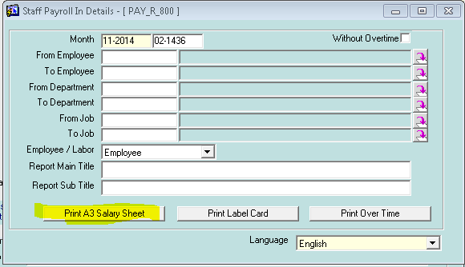

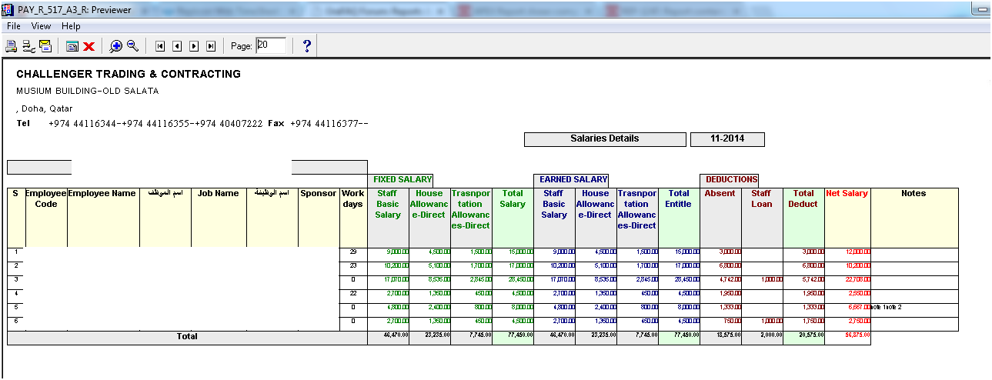

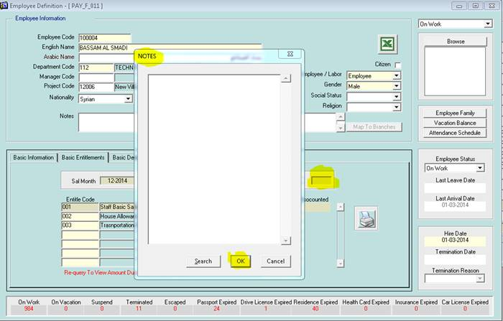

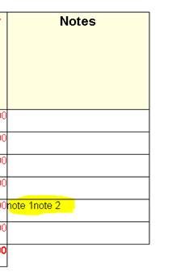

* **BANK TRASNAFER FORMAT**

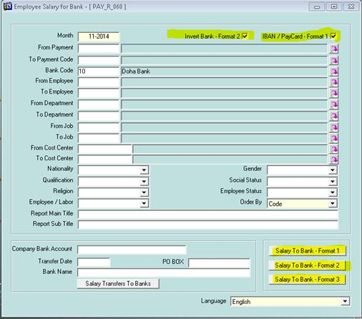

Now we have 3 layout of salary to bank

**Format 1 : list of employees grouped by bank (banks) (display IBAN / Pay Card by check the upper box)**

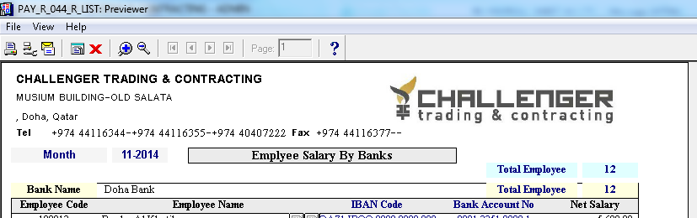

**Format 2 : landscape reports , Doha bank , or others bank  (by check the invert box)**

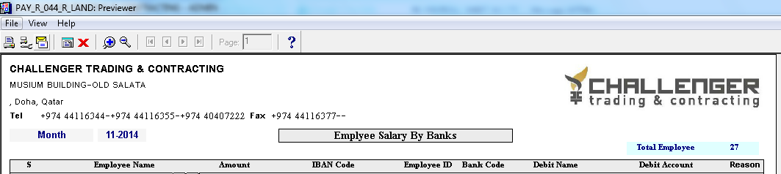

**Format 3 : D-PAY CARD reports**

I haven't got layout due to no one in my schema has pay card code

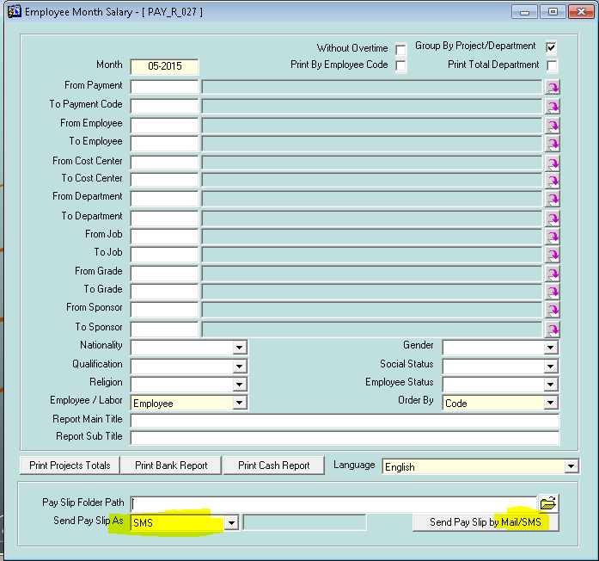

Now ,

System can send brief of salary to each employee record his mobile on system as SMS .

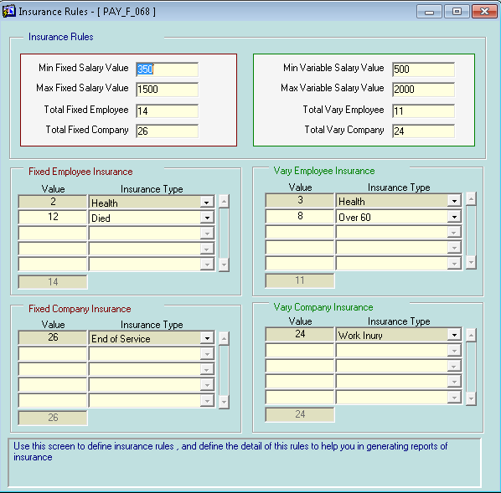

Now ,

User can define the rule of insurance as shown, and system will calculate depend on it

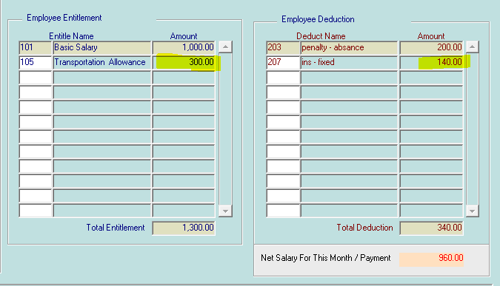

**1000** AS fixed salary will cause a deduction as fixed insurance = 14% = 140

**300** AS Variable salary will not cause any deduction as variable insurance

**University Research Add-on:**

We make the university research as a separate module , to help sale's staff and to help users who need it to have more security and more specialty.

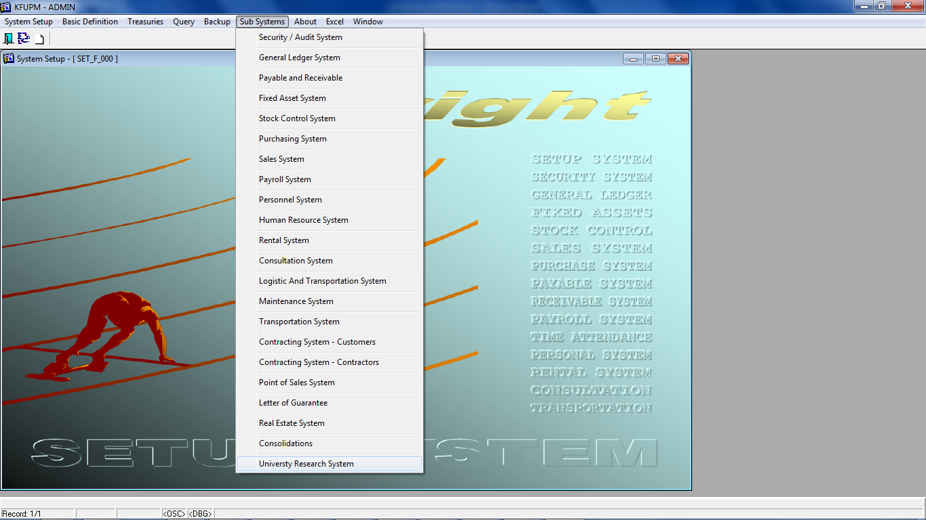

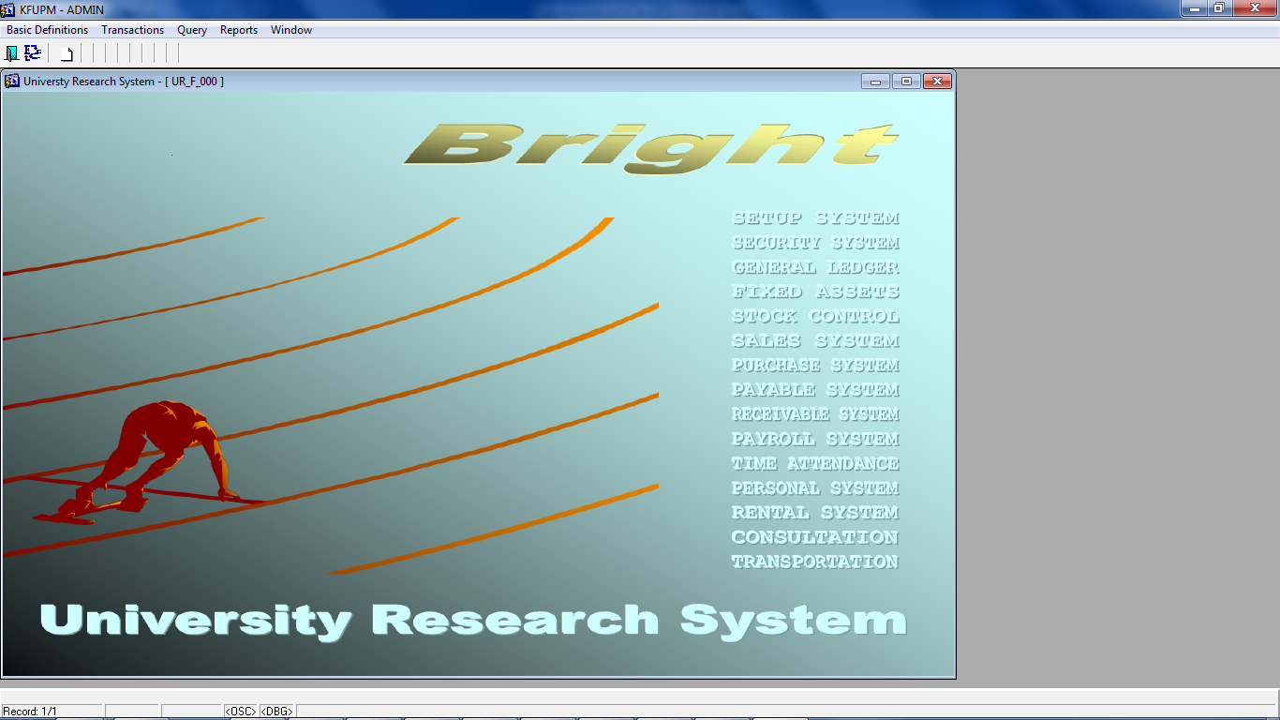

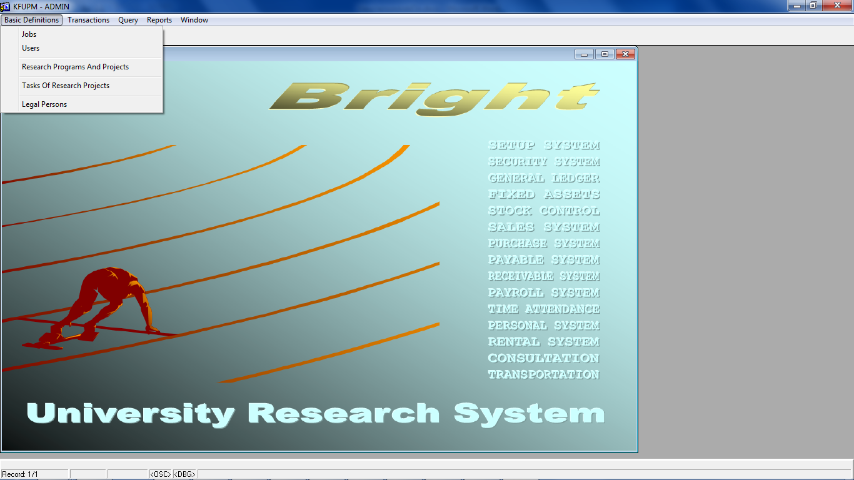 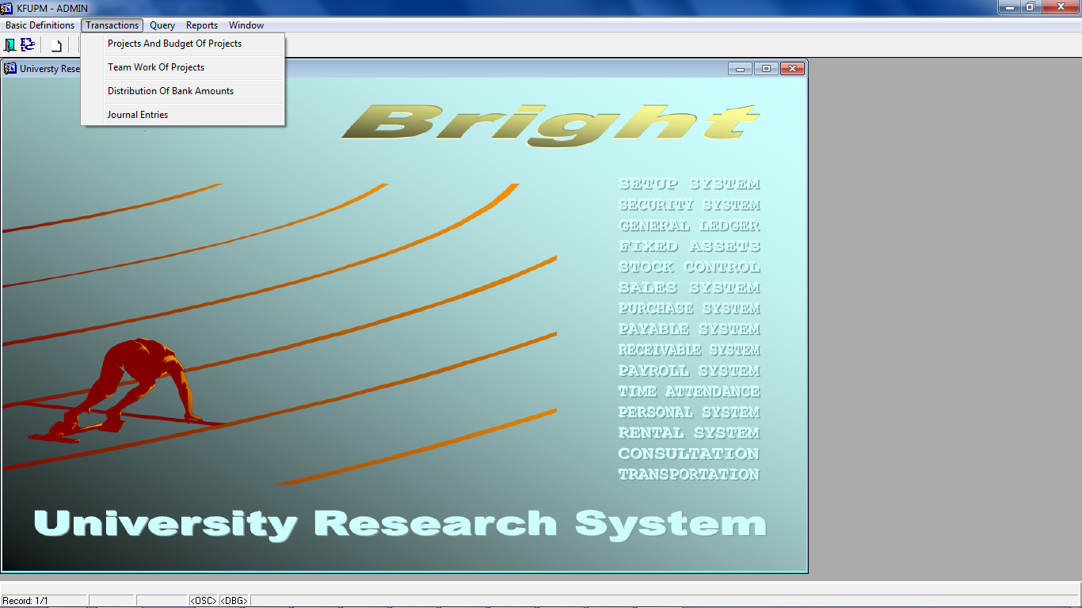 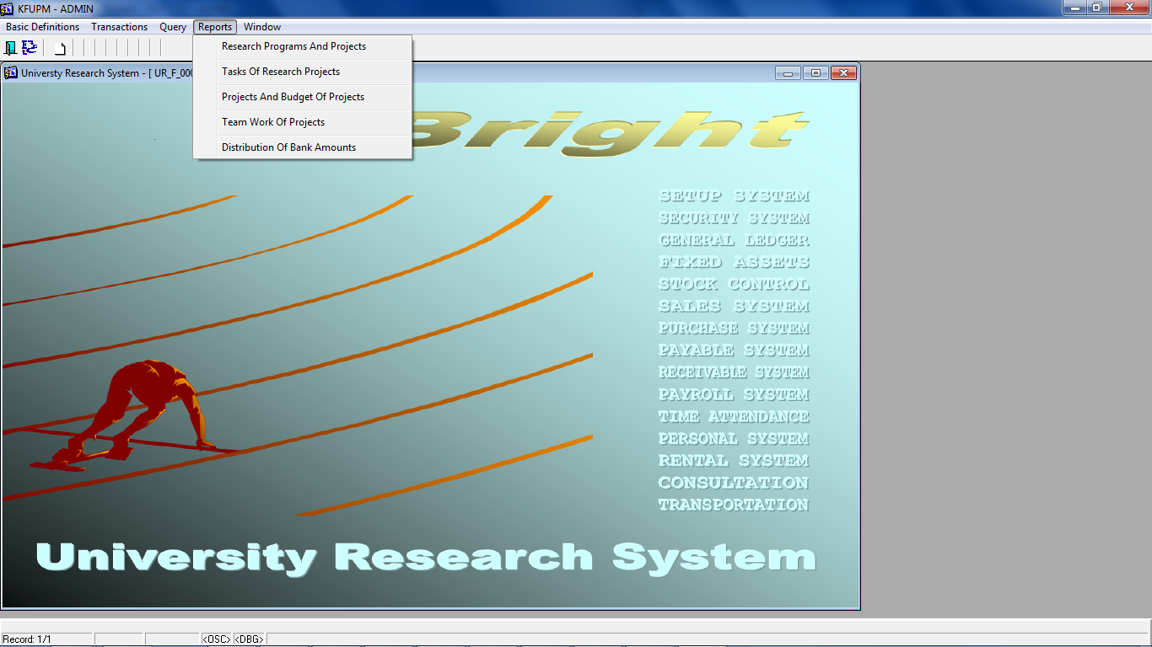

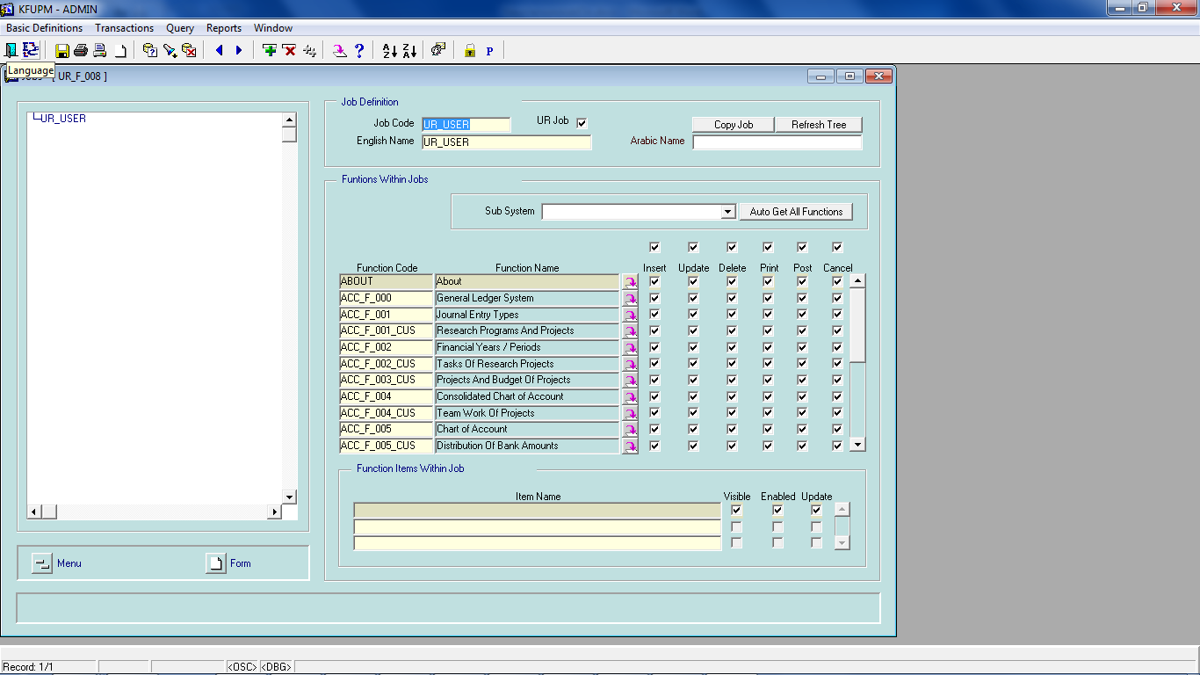

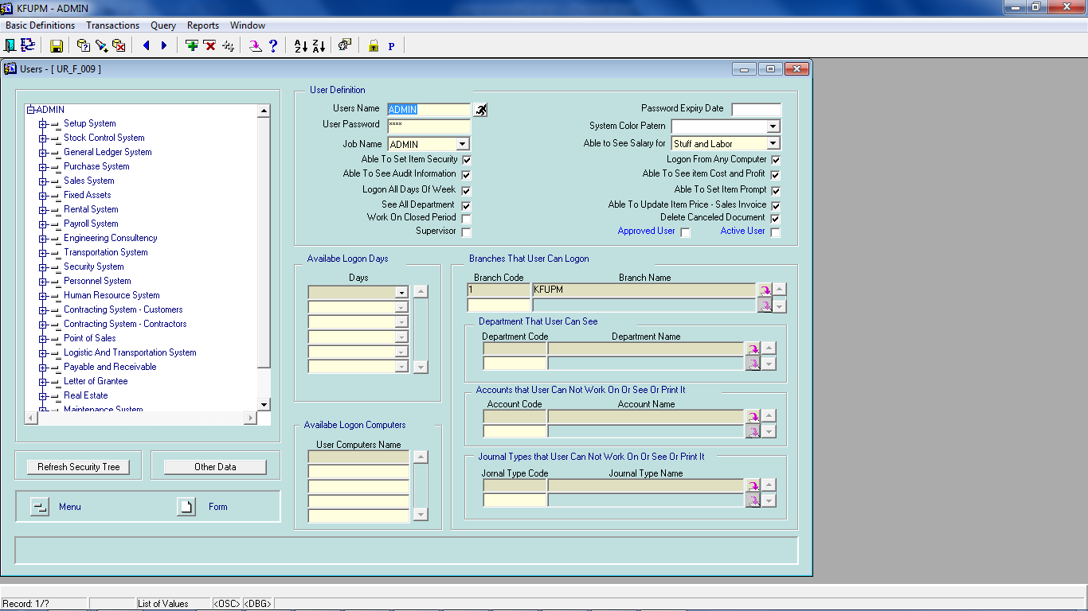

We add classification for tasks , to help user define more and more tasks (jobs) with same (or different ) class.

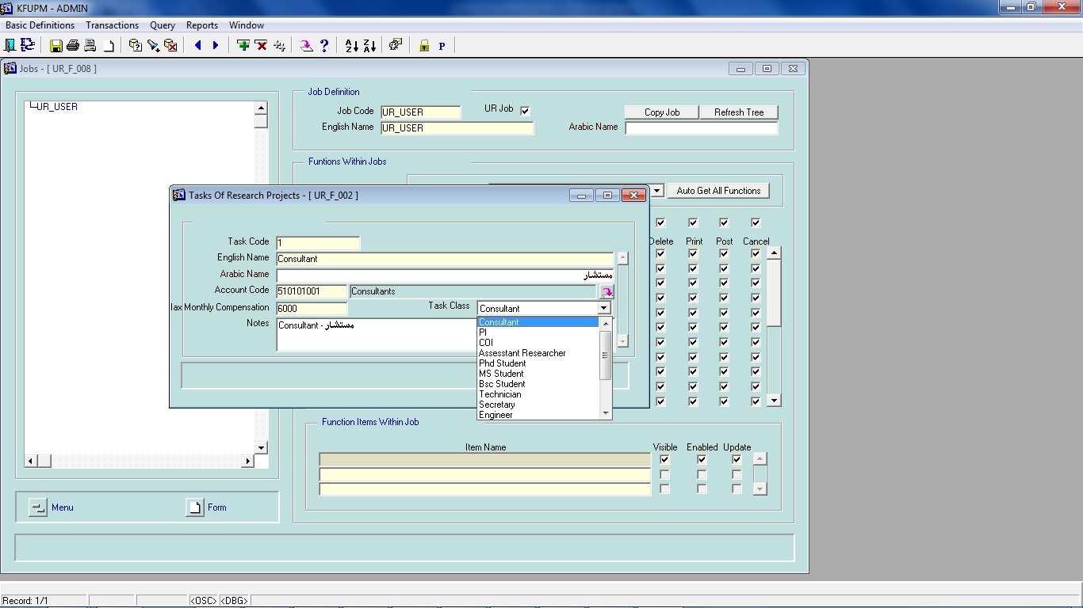

In the journal entry form , we did more specific details for the university (project management ) , as you shown below>>

**Common project , common cost center , check from date, check to date**

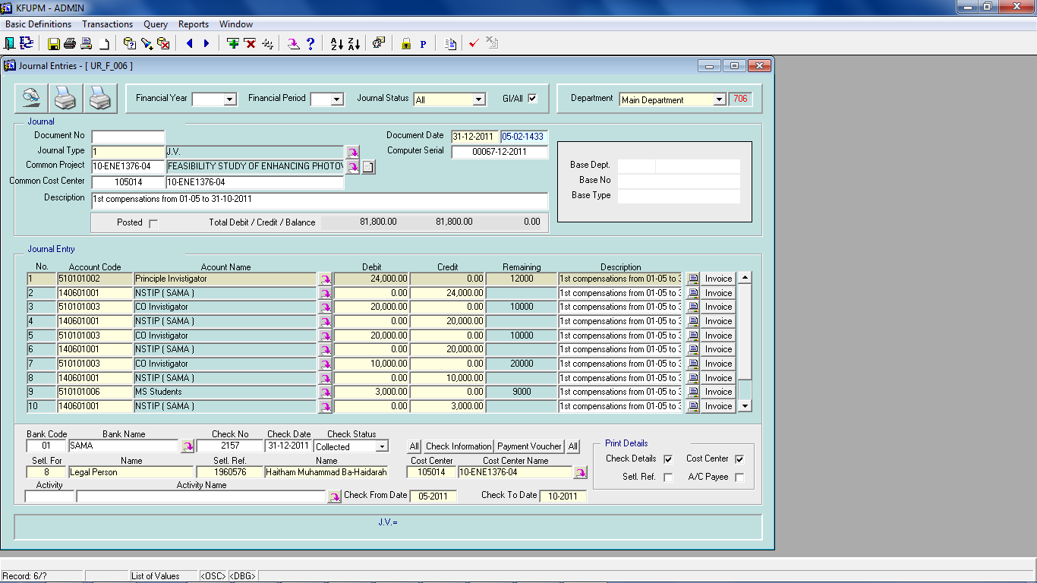

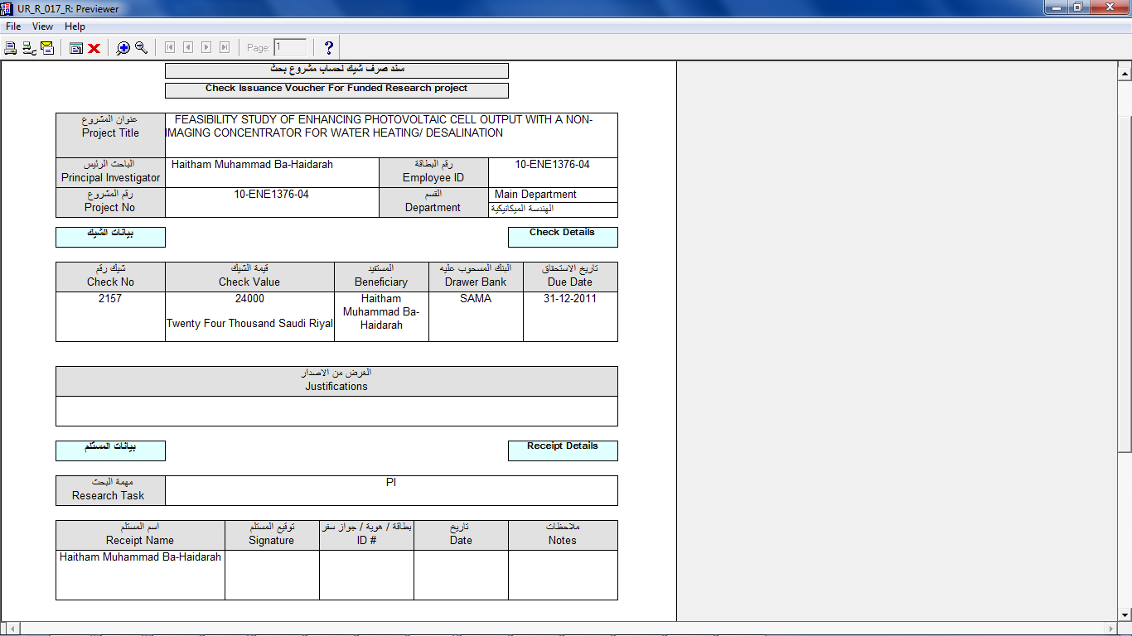

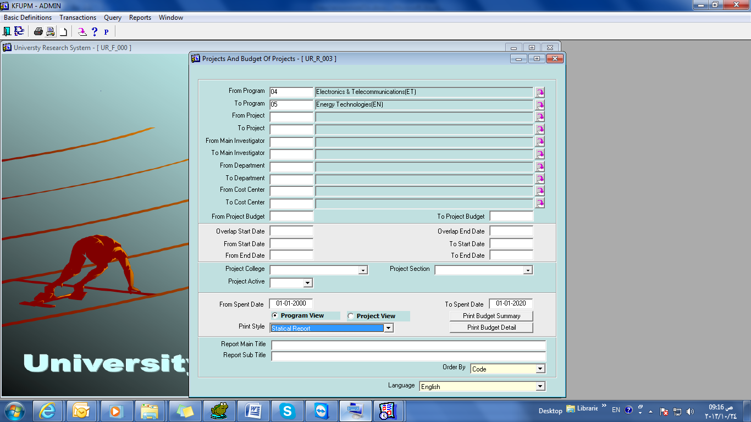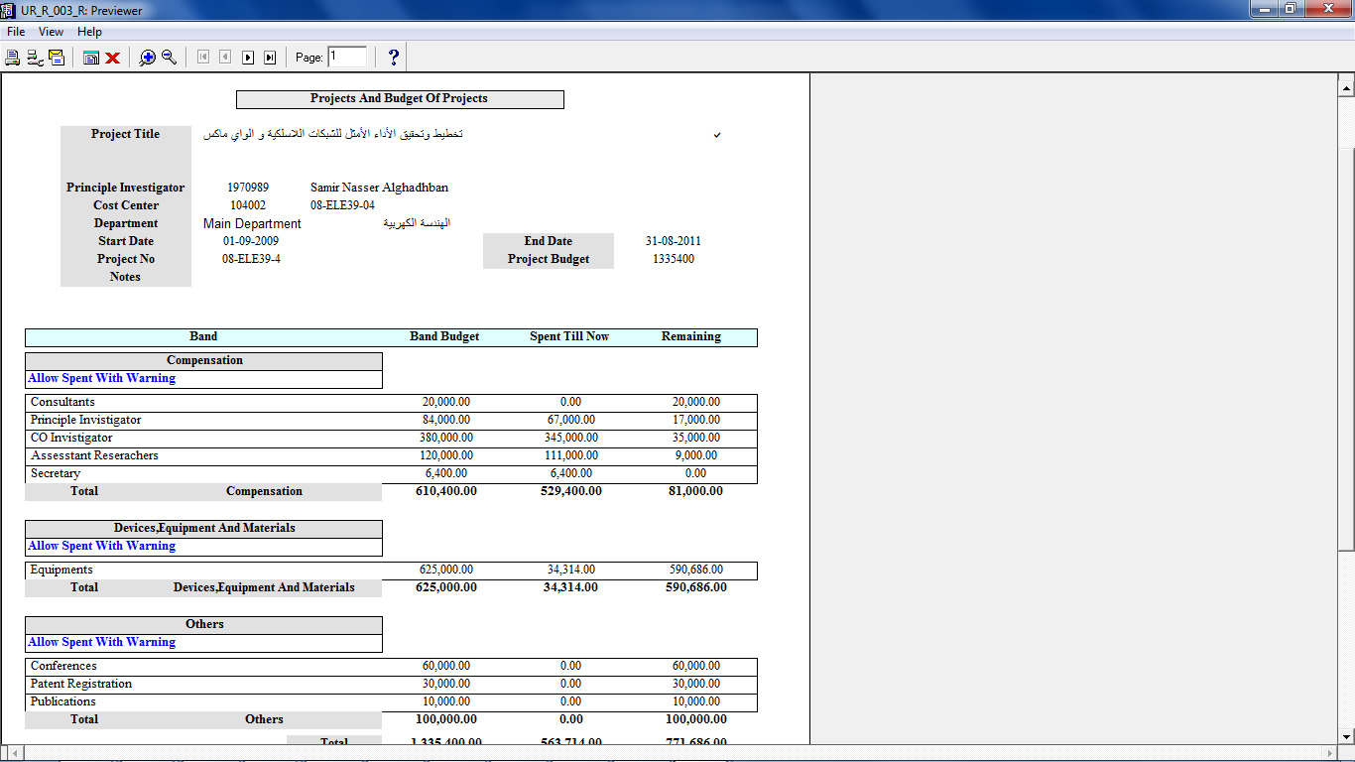

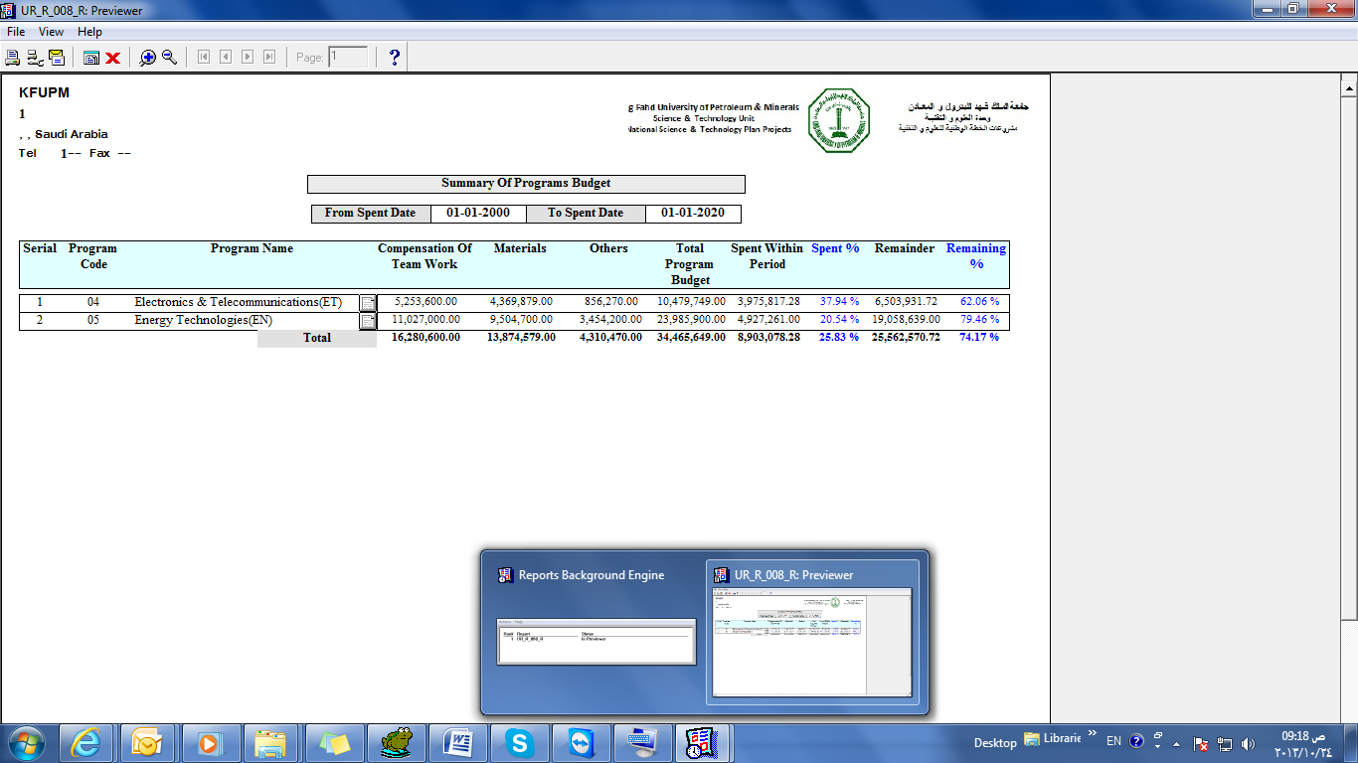

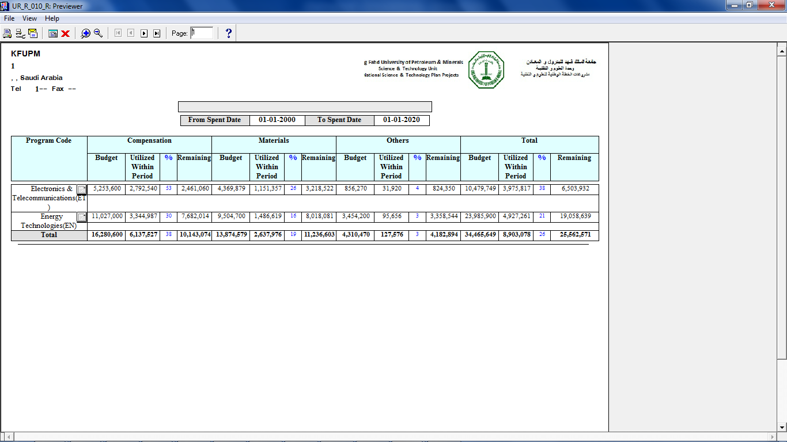

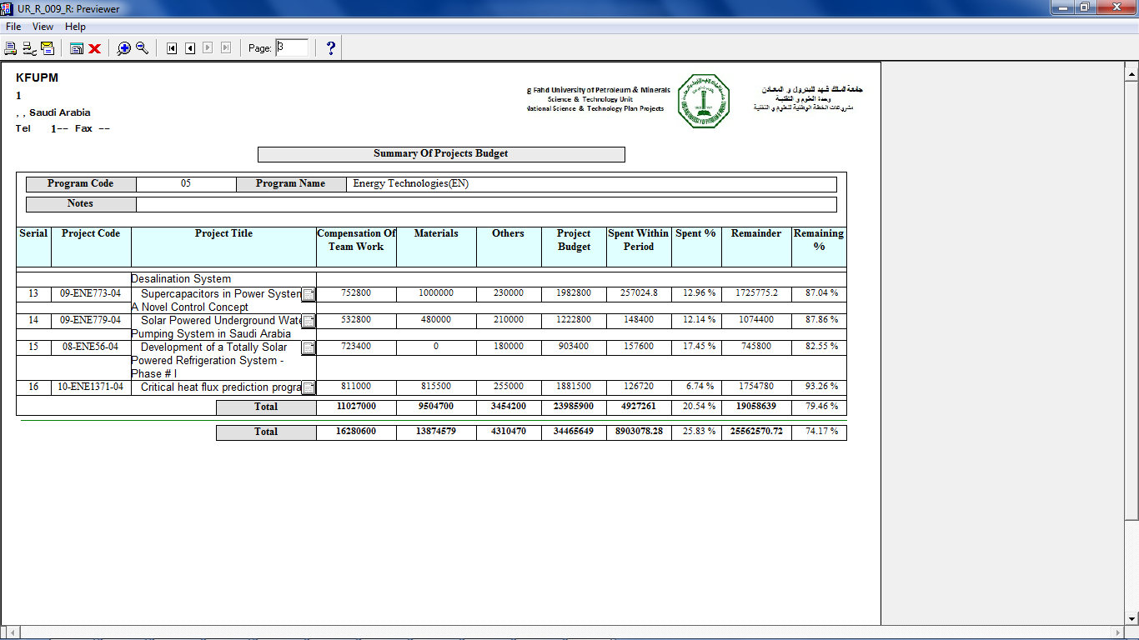

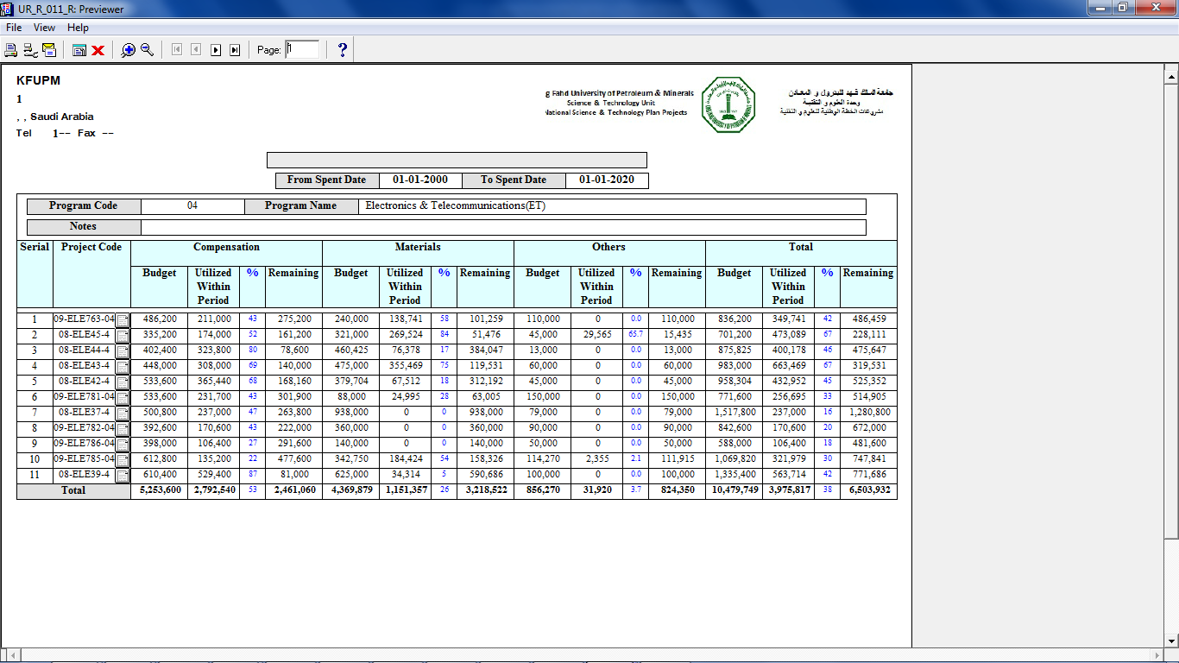

**Transportation Add-on:**

I have added some more columns to validate auto creation of delivery note from the service invoice form.

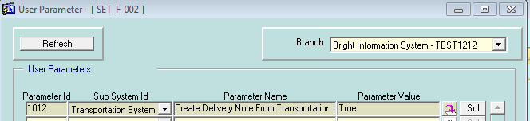

When parameter set to TRUE , the invoice form show the check box marked , and the get delivery button will be disabled as shown below …

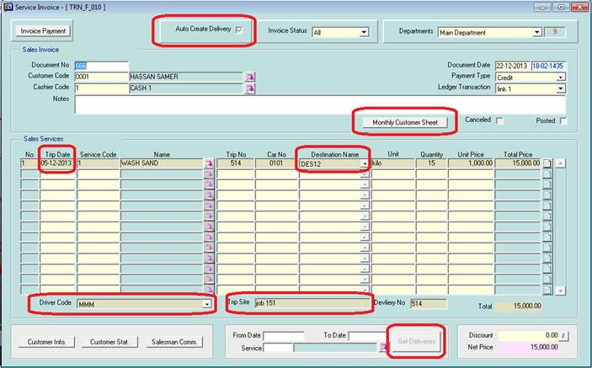

After saving , the delivery will be inserted by auto as shown below …

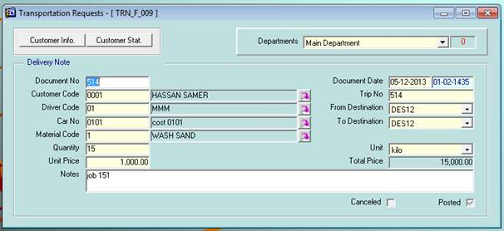

Main Report ….

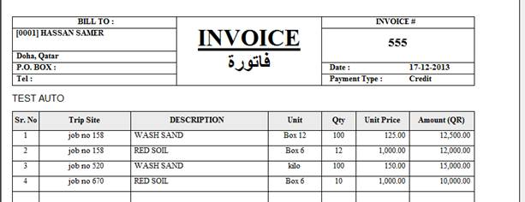

Monthly Customer Sheet ……

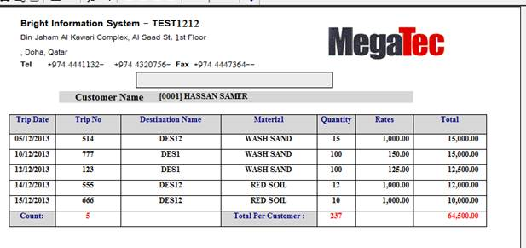

**Logistic and New Trasportation Add-On**

Basic form of Logistic/Transportation has new add-on , user can select his default port to mange which document will appear to follow up / and to filter all transportation line which start/ended by his default port .

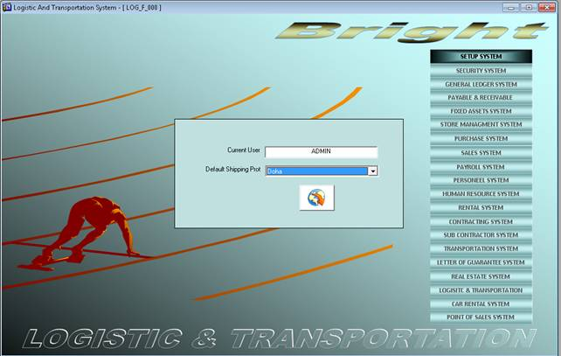

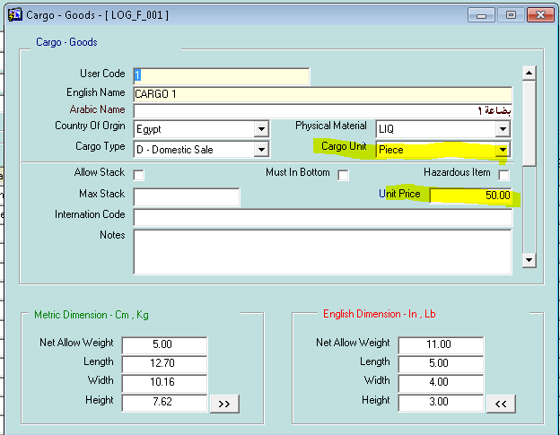

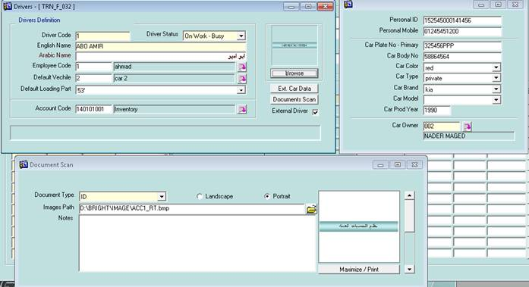

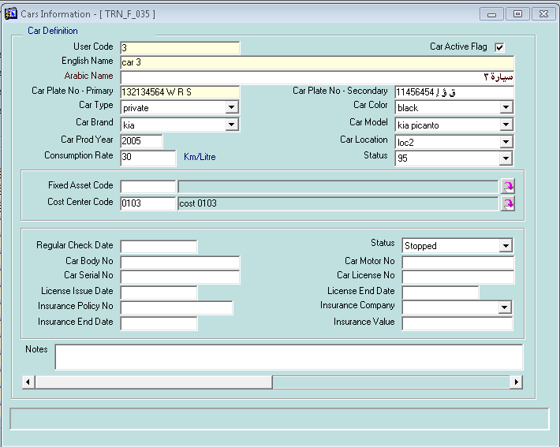

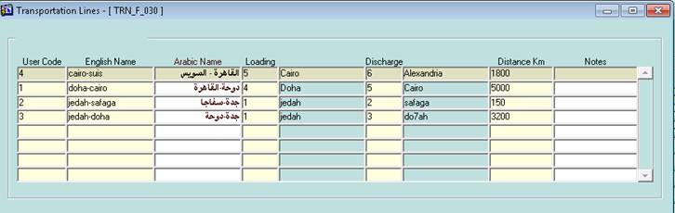

Each port has its own account , which must be used even this port is source/destination port

Each port related to certain COST CENTER which help in creation of JOURNALS

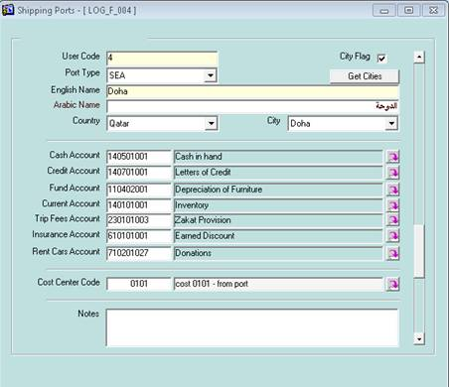

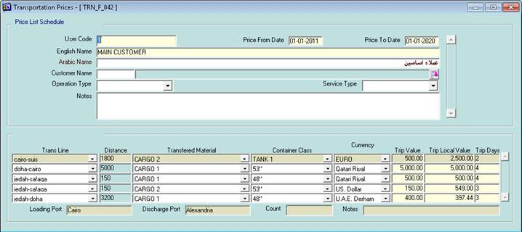

Each customer related to certain price list , which help in goods price in policy form

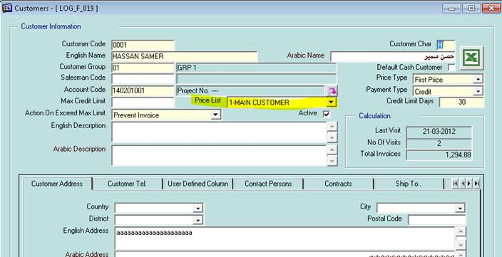

One trip may contain multiple policy (each one from customer to another)

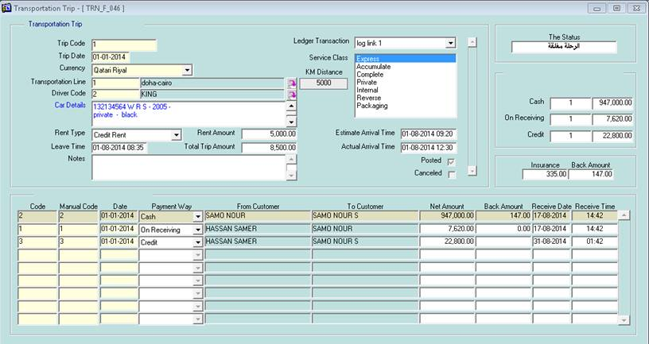

The journal was created on the whole trip , and it may has multi-payment way

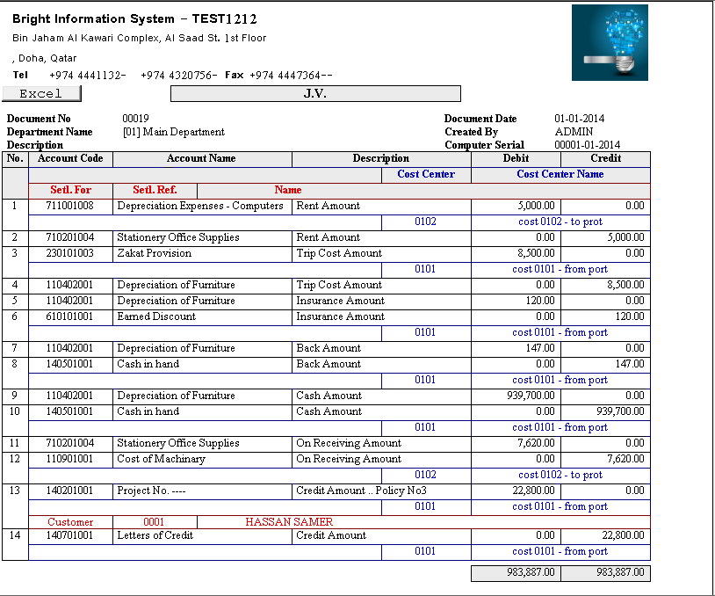

One policy may have multi goods …

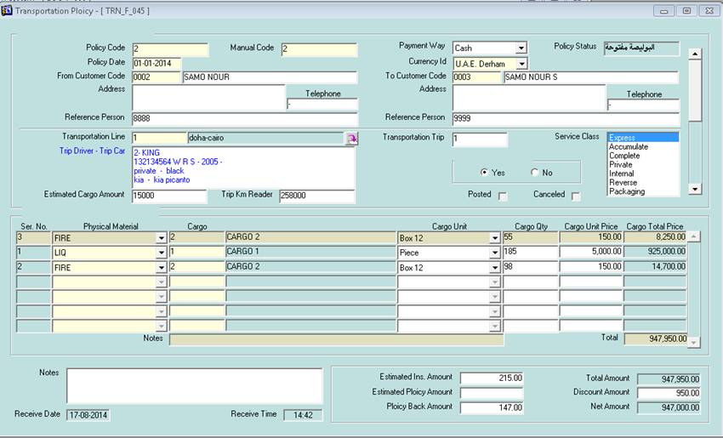

On receiving port this form help to follow up all coming policy

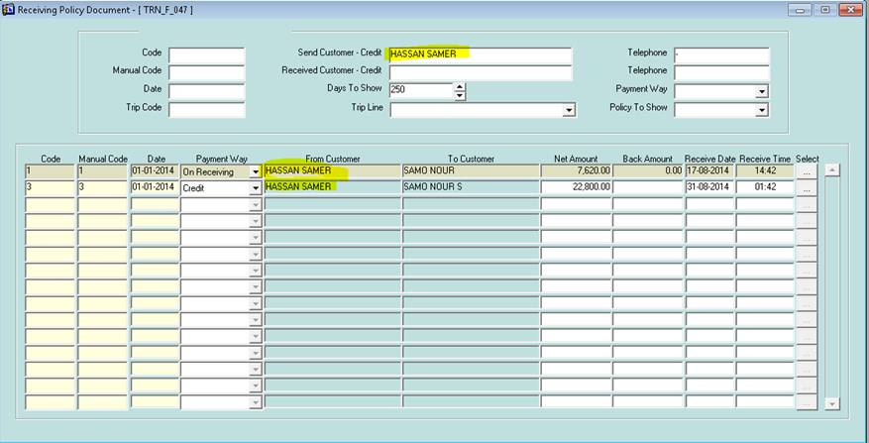

By SELECT one policy , user can edit / compelete policy receiving data .

